Biomolecules

Also referred to as

All contain the element

And are made of building blocks called | 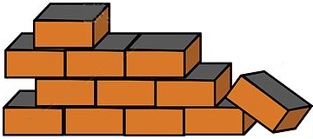  to form the large biomolecules call

B S | Glue this middle section into your notebook |  | 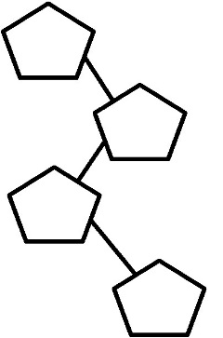  C A R
I D S  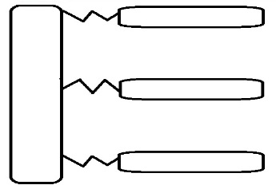 |  |  | L I P
E I NS |  |  | 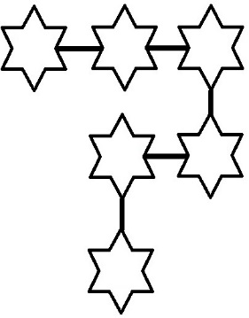  P RO T
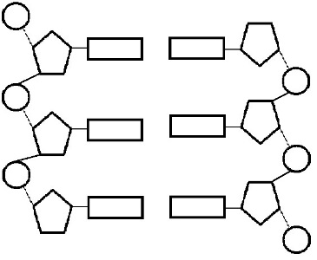  C ACIDS |  |  | NUCLEI

Monomer  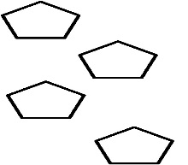 | Function | Special Notes | Examples
Monomer | Function | Special Notes | Examples
Monomer  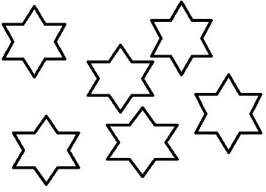 | Function | Special Notes | Examples
Monomer  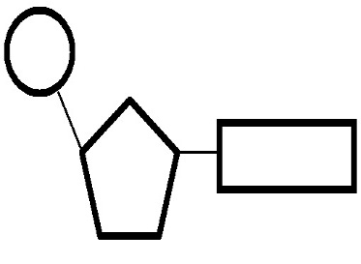 | Function | Special Notes | Examples

Biomolecules
Carbohydrates | Name of Test | Positive Test Description | Food Examples
- Monosaccharides
- Polysaccharides
Lipids
Proteins

