Accessory Organs of Digestion & Teeth
What is an accessory organ?
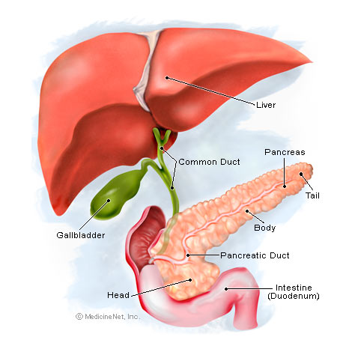
- Accessory organs produce _____________________________ that aid the organs of the alimentary canal.
- Include:
  - ___________________________ Glands
  - ___________________________
  - Liver
  - ___________________________
Salivary Glands
- Located in the ___________________________
- 2 types of cells
  - ___________________________: Produces thin, watery amalyse
  - ___________________________: Produces mucus that binds food particles together and lubricates them for swallowing.
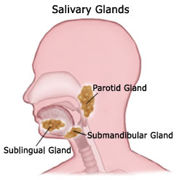
- ____________________________ + _________________________ = ______________________________
- 3 Salivary Glands:
  - _________________________
  - Submandibular
  - _________________________
Pancreas
- Large, elongated gland that lies posterior to the ________________________________.
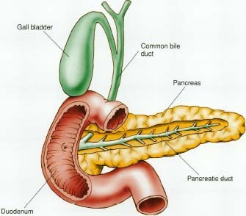
- Belongs to the ____________________________________ & __________________________________ systems.
- Produces digestive juices that travel from the pancreatic duct to the duodenum.
  - Amalyse: Breaks down ________________________.
  - Proteinase: Breaks down __________________________.
  - Lipase: Breaks down ______________________.

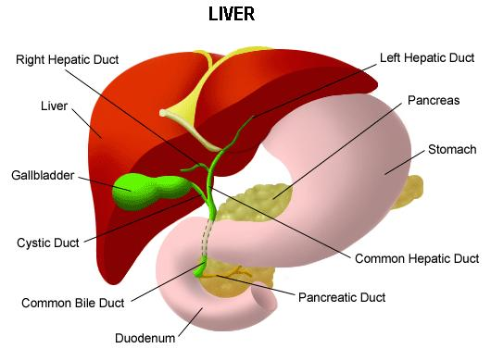
Liver
- The ___________________________ gland in the body.
- ________________________ side of the body
- Produces ________________________ to break down fats.
- Breaks down _______________________________ & drugs in the blood.
- Stores _______________________
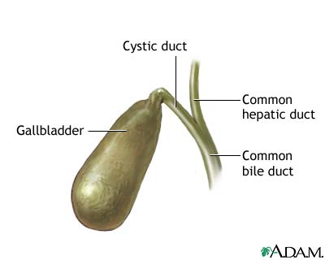
- Produces ________________________
Gallbladder
- Pear-shaped sac containing dark green ________________________.
- Located on the underside of the __________________________.
- Bile travels from the bile duct to the _________________________________.
Hormones of Digestion
- Hormones are produced and released by mucosa cells of the stomach and small intestines.
- Control Digestion:
  - __________________________: Causes the stomach to produce digestive acids.
  - __________________________: Stimulates the pancreas and liver’s bile.
  - ______________________: Causes pancreas to release pancreatic juice and the gallbladder to empty.
- Control Appetite:
  - __________________________: Stimulates appetite when there’s lack of food in the digestive tract.
  - __________________________: Inhibits appetite when the digestive system is full.
TEETH!
- 2 Sets of Teeth:
  - __________________________ (Baby) Set: _________ teeth
    - 3 yrs-6yrs.
  - __________________________Set: _________ teeth
    - 6yrs- adulthood

Types of Adult Teeth
- __________________________: Used for clipping or cutting off bites of food.
  - 8 teeth front & center of mouth (4T, 4B)
  - __________________________: Used for tearing & ripping food.
  - 4 corner teeth (2 T, 2 B)
  - __________________________ _________(Bicuspids): Used for chewing & grinding food.
  - 8 teeth behind canines (4 t, 4 B)
- ____________________________________: Used for chewing & grinding food.
  - 8 teeth behind premolars (4 T, 4 B)
- _______________________________: Used for chewing & grinding food.
  - Wisdom Teeth
  - 4 teeth behind 3rd molars (2 T, 2 B)
Anatomy of a Tooth
- A tooth has 2 divisions:
  - __________________________ White, visible part of tooth above the gumline.
  - __________________________: Below the gumline and anchors the tooth in place.
4 Tissues of a Tooth
- __________________________: Hard substance that covers the crown and protects from decay.
- __________________________: Calcified layer beneath the enamel.
- ________________________________: Covers the root and “cements” it into place in the jaw bone.
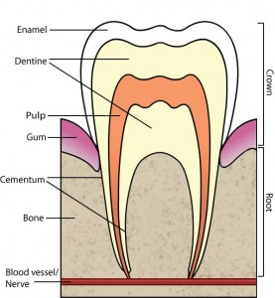
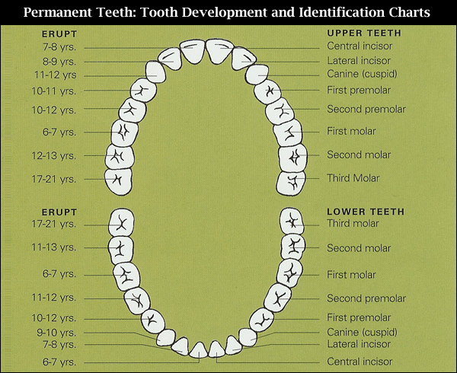
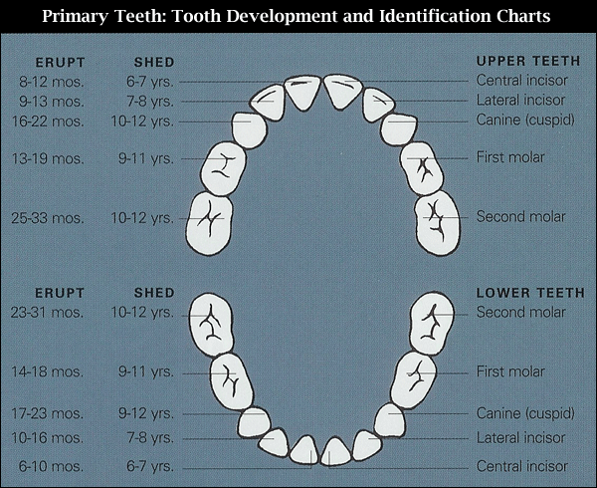
- __________________________: Center of the tooth that contains blood vessels & nerves.

