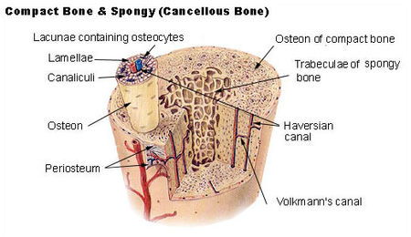
Anatomy of Bone & Joint Types
Compact Bone Under A Microscope
- Mature bone cells are called ____________________________.
- Compact bone shows a definite pattern of arrangement.
___________________________: Concentric rings formed around canals.
______________________________________: Chanel through which blood vessels run.
___________________________: Cavity where osteocytes live. Formed when matrix hardened.
______________________________________: Connects Haversian Canals.
___________________________: Connect Lacunae
Joints
- A joint is where ______________________________________________.
- Also called an ___________________________.
3 Types of joints:
  - ___________________________
  - Cartilaginous
  - ___________________________
Fibrous Joints
- Two bones meet; _________________________________ is produced.
- Ex. ___________________________in the skull
Cartilaginous Joints
- ___________________________ movement occurs
- Ex. Where ________________________________attach
Synovial Joints
- Have ___________________________ filled with fluid and allow for a great range of motion.
- ___________________________- concave/convex
- Ball & Socket Joint- Head fits into groove.
- Gliding Joint- small bones that move or glide past each other to allow quick movement.
- ___________________________: Allows bending & straightening.
- Pivot Joint: Allow rotation around an axis.
- Condyloid Joint: Allow movement but no rotation.
Classification
- Synarthroses: ____________________________________
- Amphiarthroses: Slight movement
- Diarthroses: _____________________________________
Disorders
- ______________________________ – refers to more than 100 different forms of joint pain and inflammation
  - 1 in 7 Americans has some form of it.
- ______________________________: “wear and tear” – breakdown of cartilage, bone spurs form – treat pain and encourage activity to maintain mobility
- ___________________________arthritis: autoimmune version – chronic inflammation mostly of wrists, fingers, ankles and feet
- ___________________________arthritis: uric acid crystals in soft tissue – often strikes the big toe
- ___________________________________: breaking down of bone leading to possible fractures
- ___________________________– softening of bones in children due to calcium deficiencies.
- Osteogenesis Imperfecta: AKA ______________________________________________
  - Bones fracture easily and child does not grow to normal stature
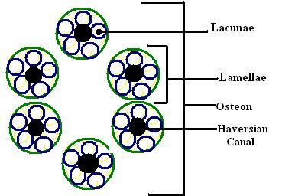
- Lordosis, Kyphosis and ___________________________: Abnormal curvatures of the spine
