Anatomy of the Brain & Spinal Cord
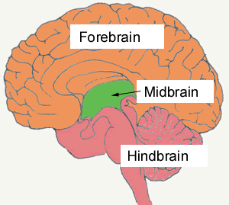
3 Major Divisions of the Brain:
- ____________________________
- ____________________________
- ____________________________
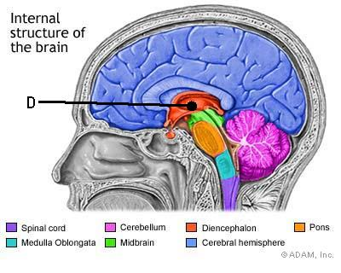
- Forebrain
- ____________________________________
  - Thalamus & Hypothalamus
  - _______________________ control & ______________________ info.
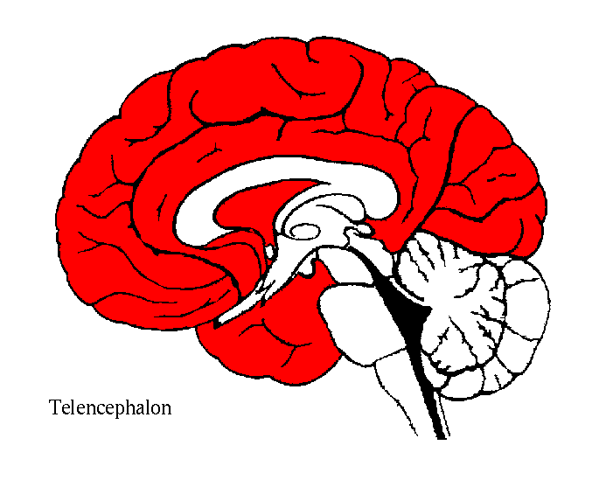
  - Controls autonomic functions
- ____________________________________
  - A.K.A “________________________________”
  - ______________________________ part of the brain
  - Location of most _____________________________ processing
- Hindbrain
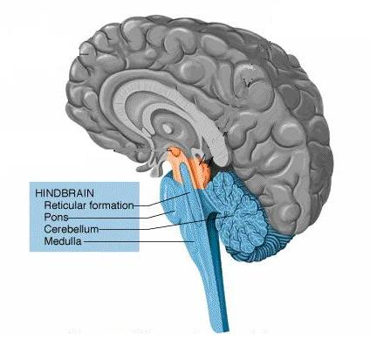
  - Extends from the ________________________________.
- _____________________________________
  - Pons
  - _______________________
  - Maintains balance & equilibrium
  - _______________________
- ____________________________________
  - _______________________________________
  - Breathing
  - Heart rate & Digestion
- Midbrain
  - ________________________ that connects the _____________________ to the hindbrain.
- _________________________& _________________________ response
- ___________________________ Function
Major Structures
- Hypothalamus: Regulates body ______________________, hunger, homeostasis.
- Thalamus: Relays __________________________ signals to & from the spinal cord and cerebrum.
- _____________________: Relay between cerebrum & cerebellum
- Medulla Oblongata: Controls _____________________________ functions
- __________________________________: Movement & Coordination
Cerebrum
- ___________________________ & ___________________________ part of the brain.
- Divided into __________ lobes.
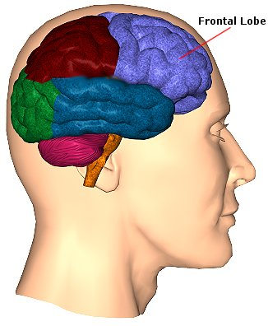
- Has ____________________ & _______________________.
  - Frontal Lobe

- __________________________
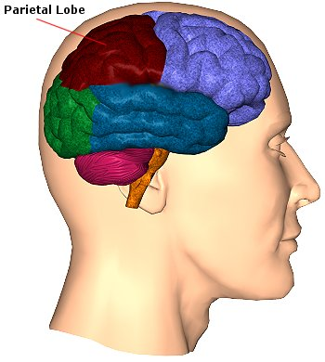
- Motor Skills
- ___________________________
- Emotions/Personality

  - Parietal Lobes

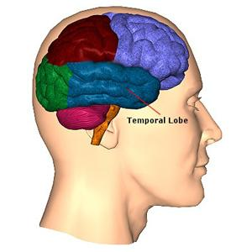
- Receives & processes sensory information. (Pain, cold, touch, etc.)
- _________________________ relationships.

  - Temporal Lobes

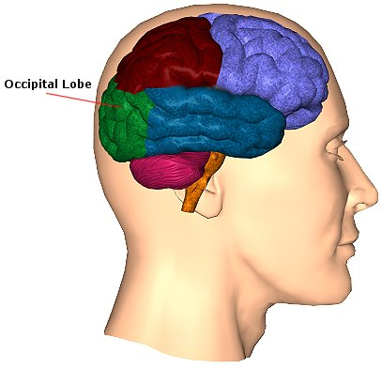
- Hearing
- Memories

  - Occipital Lobe
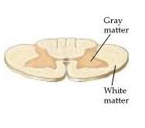
- Sight
Anatomy of the Spinal Cord
- __________________ Matter: Butterfly shaped in center of cord.
  - Large front wings contain __________________________.
  - Small back wings contain ___________________________.
- _________________ Matter: Columns of nerve fibers that surround the Gray Matter.
  - _____________________________Tract: Carry sensory information TO the brain.
  - _____________________________ Tract: Carry impulses FROM the brain to the muscles.

Diseases & Disorders
- _______________________________ disease: Progressive degeneration of the brain causing problems with memory, thinking, & behavior.
- Cerebral ____________________________: Excess accumulation of water surrounding the brain.
- Cerebrovascular __________________________: A.K.A. Stroke. Death of brain cells due to a lack of blood flow caused by an obstruction.
- ____________________: A state of complete unresponsiveness.
- ______________________________: Destruction of brain tissue due to trauma.
- ______________________________: Bruising of the brain.
- Intracranial ______________________: Rupture of a blood vessel causing blood to pool around the brain.
- Multiple _________________________: Degeneration of the myelin sheath causing nerve impulses to slow/stop.
- Transient ____________________ attack: Warning/Mini stroke.

