Digestive System Web Activity
http://tinyurl.com/cszv9dk

Name: ____________________________________ Date: ____________________
1. Medtropolis Virtual Body:
Click on English or Spanish. Click on Digestive Tract.
Take the Guided Tour. List 5 important facts from this section:

Click on Zoom In
Label the Following Diagrams:
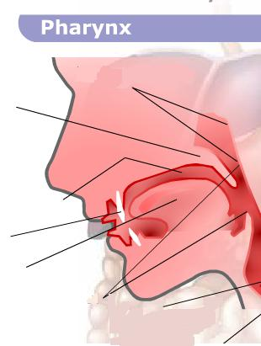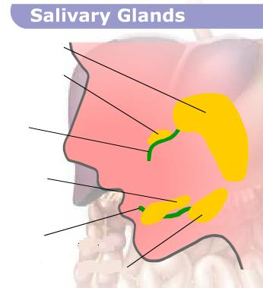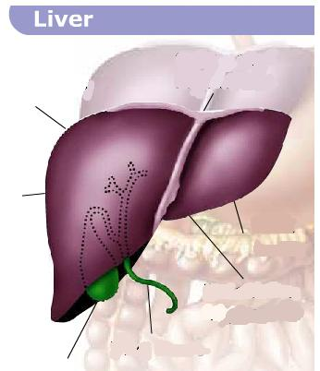
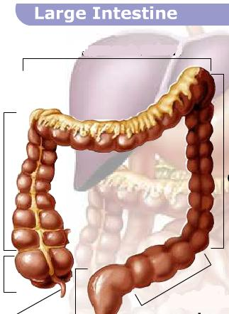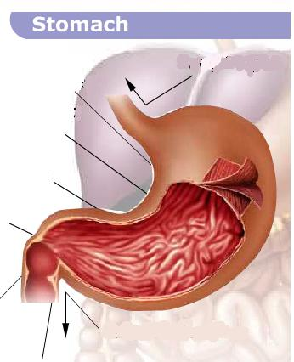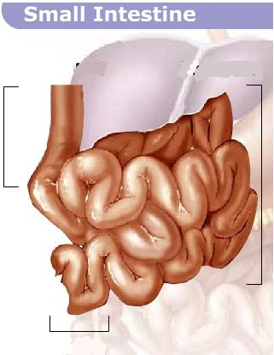
Digestion & Absorption Animation:
Choose 2 foods and record what happens at each step of digestion:
Food 1: _____________________________________ | Food 2:________________________________________

McGraw Digestion Video: Put a check in the box after watching the entire clip.
Inner Body Digestive System: Click on Male of Female
Click on Teeth:
The second set of teeth, called secondary or permanent teeth, consists of ___________ teeth-sixteen in each jaw-and they are arranged from the midline of the mouth as follows: ________________________________, ___________________________, ____________________________, first bicuspid (premolar), second bicuspid, __________________________________, second molar, and third molar.
Adult teeth form very slowly and push up through the gums when they are fully formed. Permanent molars (grinding teeth) appear behind the primary premolars, where a child has no teeth at all. ______________________________________ dislodge and take up the space of the eight primary molars, and adult incisors and cuspids (sharp, chisel-shaped, biting teeth) replace baby teeth of the same kind. When baby teeth fall out, the roots are absorbed into the gums. The first permanent teeth are frequently known as _______________________________________, because they appear at around that age. The process of shedding baby teeth begins at about that time too, with the front teeth as the first to go. The upper canines are the last baby teeth to be lost. By the age of eleven to thirteen, twenty-eight permanent teeth are usually in place. The four additional adult, or wisdom, teeth appear several years later; or, sometimes, they do not appear at all. Sometimes these molars, called wisdom teeth, become wedged in abnormal positions within the jaws and fail to erupt. Such teeth are said to be ________________________.
Different teeth are adapted to handle food in different ways. Incisors (front teeth) are ________________________________, and their sharp edges bite off relatively large pieces of food. The cuspids (canine teeth) are ____________________________, and they are useful in grasping or tearing food. The bicuspids and molars have somewhat ______________________________ and are specialized for grinding food.
The ___________________________________ that covers the _________________________, the part above the gum, in each tooth can be broken down by ________________________ produced by the mouth for digestive purposes. This process is called ______________________________. To prevent decay, good oral hygiene, consisting of daily brushing and flossing, is necessary. The hardest substance in the human body is one of the four kinds of tissue that make up the tooth. It is enamel and covers the crown, the area above the gum line, of the tooth. A bony material called ______________________________ covers the root, which fits into the jaw socket and is joined to it with membranes. ____________________________ is found under the enamel and the cementum, and this material forms the largest part of the tooth. At the heart of each tooth is living __________________, which contains nerves, connective tissues, blood vessels and lymphatics. When a person gets a toothache, the pulp is what hurts.
Click on Plaque:
Plaque is ____________________________ and their products, which form a sticky, concentrated film that adheres to the teeth. The part of the tooth next to the sulcus is extremely difficult to keep free of bacterial plaque, and if not removed constantly, or left undisturbed for a few days, will form ________________________ - a rough, hard material that adheres to teeth. Plaque and tartar build-up constitute the primary cause of periodontal disease.
Click on Gingivitis:
Gingivitis is gum _______________________________. It's also the first stage in periodontal disease. The gums may become reddish or purple and slightly swollen. They may be tender and they may bleed easily. You may have a ___________________________, and your breath may be _______________________________. You may have no symptoms.
Once Upon A Life….Digestion: Summarize what happened in each of the 3 clips:
Part 1: | Part 2: | Part 3:

Order Test | Order List | Label Diagram 1
1. | 1. | 1.
2. | 2. | 2.
3. | 3. | 3.
4. | 4. | 4.
5. | 5. | 5.
6. | 6. | 6.
7. | 7.
8. | 8.
9. | 9.
10. | 10.
Label Diagram 2 | Label Diagram 3 | Label Diagram 4
1. | 1. | 1.
2. | 2. | 2.
3. | 3. | 3.
4. | 4. | 4.
5. | 5. | 5.
6. | 6. | 6.
7. | 7. | 7.
8. | 8. | 8.

Mission Nutrition
- What drink has the most sugar added?
  - How much sugar?
- Which snack provides the best source of carbohydrates and protein? (Hint: Look in cabinet)
- Click on the fruit bowl:
  - What nutrition is provided in oranges?
  - What nutrition is provided in grapes?
  - What nutrition is provided in apples?
  - What nutrition is provided in bananas?
Take the quiz:
What other foods contain lots of vitamin C

