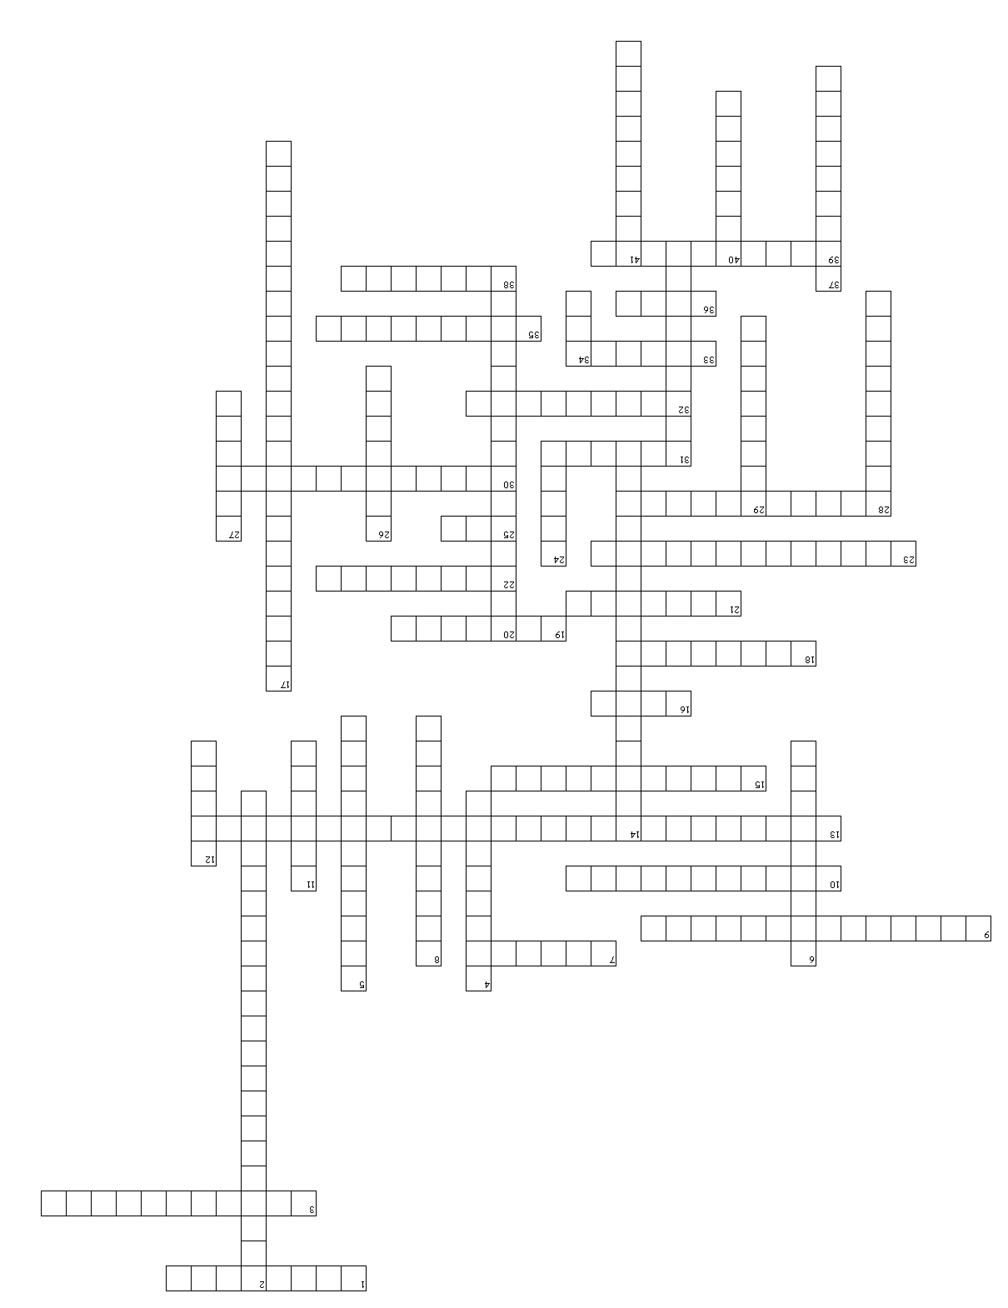
Endocrine, Blood, & Heart Test Review
Please remember to study the following diagrams:
- Hormone Chart
- Endocrine Gland Locations
- Heart Anatomy
- Blood Flow Pathway

Test Review
Endocrine System, Blood, & Heart
Across
- A clot that develops and persists in an unbroken blood vessel.
3. Rapid heartbeat over 100bpm.
7. Condition that lowers the amount of oxygen carried by RBC’s.
9. Chest pains caused by lack of oxygen to the heart.
10. The specific organ affected by a particular hormone.
13. Hormone that stimulates production of ova & sperm.
15. Slow heartbeat less than 60 bpm.
16. The pointed tip of the heart that points down toward the left hip.
18. Relaxation of the heart.
19. White blood cells have one, red blood cells do not.
21. Hormone that raises blood glucose.
22. Hormone that stimulates contraction of the uterus and milk “letdown” reflex.
23. Hormone that stimulates growth.
25. Closing of the Semilunar valves.
28. The sac that covers the heart.
30. Another name for red blood cells.
31. Liquid portion of blood.
32. Hormone that stimulates metabolism.
33. The gland that secretes melatonin.
35. Hormone that supports sperm formation.
36. The wider top portion of the heart.
38. A traveling blood clot.
39. Another name for white blood cells.

Down
- Heart attack.
4. The gland that secretes insulin & glucagon.
5. Adrenaline hormone that gives “superhuman” strength in stressful situations.
6. Hormone involved in rhythmic activities.
8. Bottom two chambers of the heart.
11. Sound created by improper blood flow usually caused by valve problems.
12. Carries deoxygenated blood to the heart.
14. Disease in which RBC’s are crescent shaped instead of round.
17. the wall that divides the heart longitudinally.
20. Another name for your heart strings.
24. The top two chambers of the heart.
26. Gland that secretes epinephrine & norepinephrine.
27. The gland that secretes androgens.
28. Hormone that stimulates milk production.
29. Carries oxygenated blood away from the heart.
31. Gland that secretes oxytocin, growth hormone, prolactin, luteinizing & follicle-stimulating hormone.
34. Closing of the Atrioventricular valves.
37. Responsible for clotting blood.
40. Gland that secretes estrogens.
41. Hormones that stimulate uterine lining growth.

