Excretory System
Kidney Location
- Located near on the left & right sides of the ____________________________ at the small of the back.
- Kidneys are _________” long & _________” wide.
- Left kidney sits _____________________ than the right due to the large size of the _______________.
Kidney Physiology
- _____________________________ of waste products
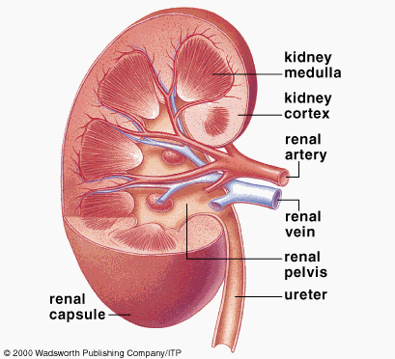
- Maintenance of ___________________________________ in the body
  - Balance of water in the blood.
  - Balance of electrolytes in the blood.
  - Regulates pH of blood.
- Release of important ______________________________
Kidney Anatomy
- Outer ________________________
- Inner _________________________
- Renal Artery: Receives ________________________________ blood
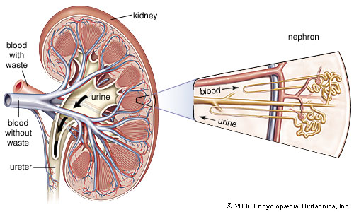
- Renal Vein: Removes _________________________________ blood
- _____________________________: Make urine
Nephrons
- Major functional unit
- Makes urine by:
  - ________________________________blood of water, salt, glucose & urea
  - _________________________________ useful solutes back into the blood stream.
  - Allowing waste molecules to filter into __________________________________.
Kidney Hormone Function
- _____________________________: Increases reabsorption of ions & water in the kidney.
- Erythropoietin: Acts on bone marrow to increase production of ___________________________ cells.
- Calcitriol: Promotes the absorption of ________________________ from the food in the intestines and acts directly on bones to shift calcium into the blood stream.
Ureters
- ____________ inch slender tubes that connect the kidneys above to the urinary bladder.
- Transport __________________________ to the _______________________
- Ureters contain _________________________ muscle tissue and
  - about every _____________ seconds, peristaltic contraction sends urine to bladder!
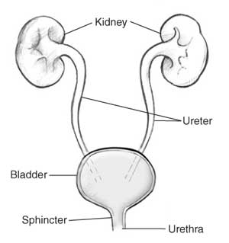
- Uretal openings are _________________________, to prevent backflow of urine into kidney
Bladder
- ____________________________ sac that temporarily stores urine.
- Connects to the ______________________
- Can hold up to _________________________ of urine
- Has an internal & external _______________________
Urethra
- Thin-walled tube that carries urine from the ________________________ to the outside of the body.
- Located above the ________________________opening in females (_______ inch in length)
- Serves to carry urine and _________________ out of the penis in males (___________ inches in length)
- ______________________________________: The act of urinating.
Disorders
- Urinary Tract Infections: ________________________ invades the urethra & bladder. Much more common in females than males because it is shorter and positioned closer to the anus.
- Kidney Stones: ___________________________ deposits, magnesium salts, or crystal of uric acid can form solids within the ____________________________ or _______________________.
- Incontinence: Inability to _____________________________ urination
  - Babies, women after birth, elderly

