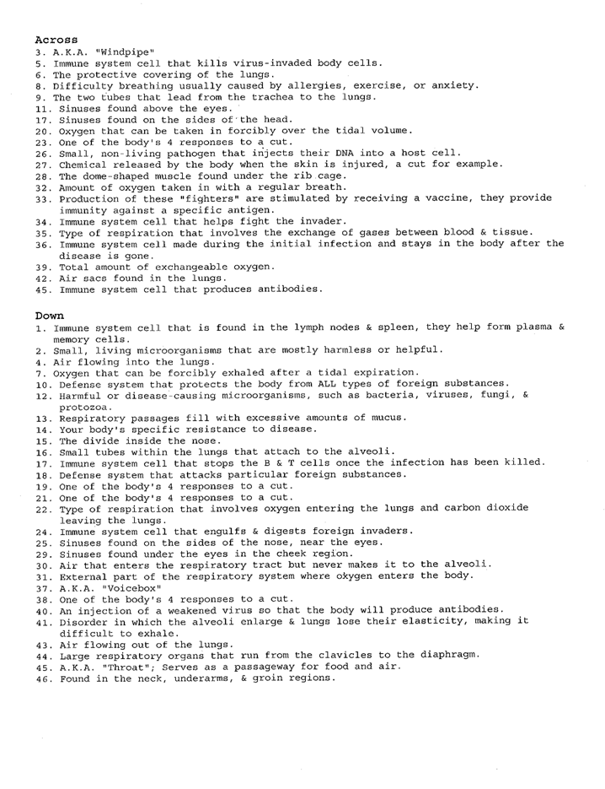
Autoimmune Disorders Matching:
Description | Disease
- _______ Inflammation of the liver that occurs when immune cells mistake the liver’s normal cells for harmful invaders and attack them. | - Addison’s Disease
- _______ A disease that your immune system attacks your thyroid gland, causing you to overproduce thyroxine. | - Alopecia Areata
- _______ The islet cells of the pancreas are destroyed and lose their ability to produce insulin for our bodies. | - Autoimmune Hepatitis
- _______ The body mistakes bacteria, food, and other substances for being foreign causing inflammation of the digestive tract. | - Celiac Disease
- _______ A disorder involving pain and stiffness in the hip or shoulder area. | - Crohns Disease
- _______ A chronic inflammatory disease that can affect joints, skin, kidneys, blood cells, heart & lungs. | - Goodpasture’s Syndrome
- _______ Inflammatory disease that may develop after an infection with Streptococcus bacteria that can affect the heart, joints, skin, and brain. | - Graves Disease
- _______ Autoimmune disease of the connective tissue, causes the skin to tighten and harden, fingers can curl and lose their mobility. | - Lupus
- _______ A disorder in the adrenal glands that render the glands from producing enough hormones. | - Mellitus
- _______ Disorder that causes inflammation of your blood vessels, restricting blood flow to organs most commonly affecting the kidneys, lungs, and upper respiratory tract. | - Multiple Sclerosis
- _______ Disorder caused by damage to the myelin sheath affecting the brain & spinal cord. | - Polymyalgia Rheumatica
- _______ Digestive disease that damages the villi of the small intestine when the infected person digests glutens. | - Rheumatic Fever
- _______ Disease that attacks the lacrimal and salivary glands causing dry eyes and mouth. | - Rheumatoid Arthritis
- _______ Disorder in which the body’s immune system attacks the lungs & kidneys. | - Scleroderma
- _______ Hair loss/balding condition that results in loss of hair on the head and /or body. | - Sjogren’s Syndrome
- _______ A long term disease that leads to inflammation of the joints and the tissues that surround them. | - Wegener’s Granulomatosis

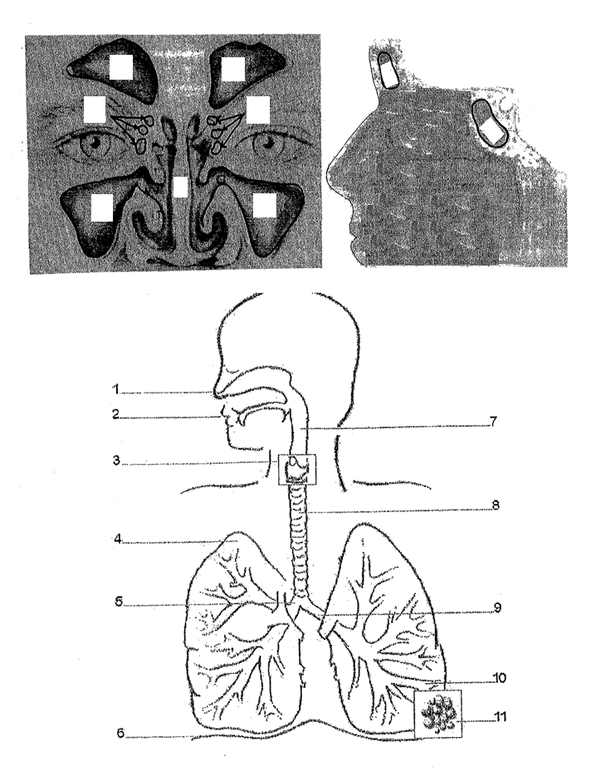

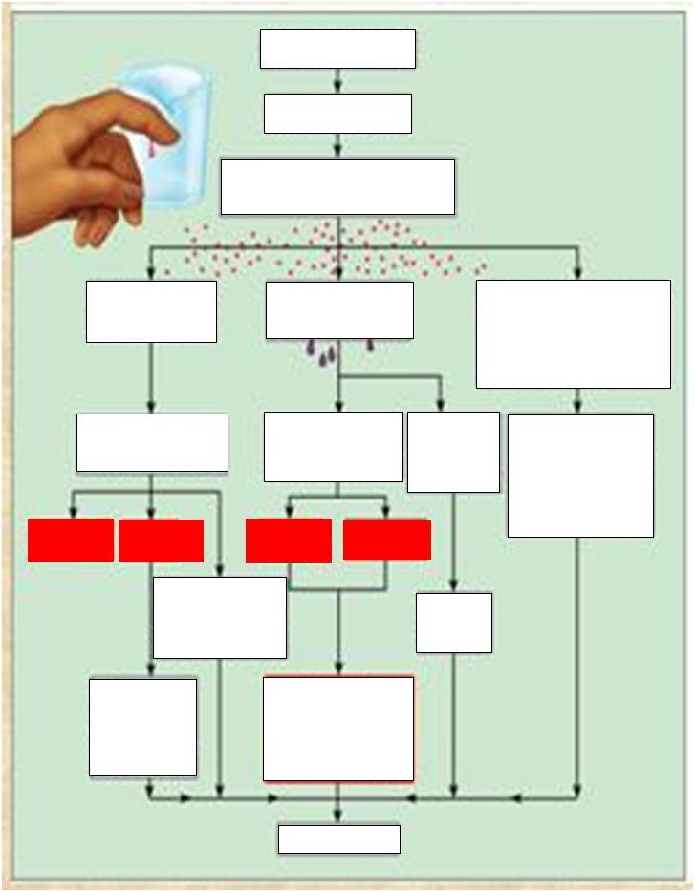

Word Bank for Flow Chart
- Release kinins, histamine, & other chemicals
- Edema (fluid in tissue spaces)
- Capillaries become leaky
- Redness
- Increased blood to the area
- Fibrin barrier
- Removal of damaged/dead tissue cells and pathogens from area
- Swelling
- Injurious Agents
- Pain
- Possible temporary limitation of joint movement
- Clotting proteins enter area
- Healing
- Neutrophils, monocytes, & other white blood cells enter the area
- Increases metabolic rate of tissue cells
- Brings more nutrients and oxygen to the area
- Cells Damaged
- Heat
- Blood vessels dilate

Word Bank for Flow Chart
- Release kinins, histamine, & other chemicals
- Edema (fluid in tissue spaces)
- Capillaries become leaky
- Redness
- Increased blood to the area
- Fibrin barrier
- Removal of damaged/dead tissue cells and pathogens from area
- Swelling
- Injurious Agents
- Pain
- Possible temporary limitation of joint movement
- Clotting proteins enter area
- Healing
- Neutrophils, monocytes, & other white blood cells enter the area
- Increases metabolic rate of tissue cells
- Brings more nutrients and oxygen to the area
- Cells Damaged
- Heat
- Blood vessels dilate

