3.6 Intro To Tissues
Objectives:
- Be able to determine the functions & characteristics of Epithelial Tissues
- Visualize how Epithelial Tissue is classified.
- Determine where in the body each type of Epithelial Tissue is located.

Remember, tissues are made up of cells!
- Cells connect with one another to form a tissue via a variety of junctions. Individual cells may have more than one type of junction.
- _________________________ Junctions: Cells join together VERY tightly. Ex. In the intestine, so that the bacteria cannot penetrate.
- _________________________Junctions: Spaces or “gaps” between cells that facilitate the flow of molecules. Ex. Calcium between cells.
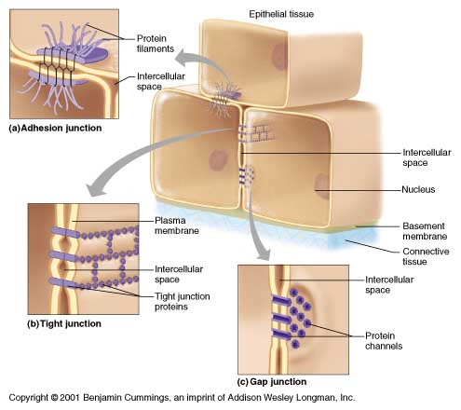
- _________________________Junctions: Others act like "staples" to hold the cells together in the tissue. Ex. Skin Cells
There are 4 primary tissue types:
- Epithelium: _________________________
- ____________________________________: Support
- Muscle: _________________________
- ____________________________________: Control
Epithelium
- There are 2 types of Epithelial Tissue:
  - __________________________________________ Epithlium covers the surface of the outside of the body and lines internal organs.
  - __________________________________________ Epithlium secretes hormones or other products.
- Functions: _____________________________, Absorption, ________________________________ & Secretion
Characteristics
- Fit _________________________together to form continuous sheets (Tight Junctions/Adhesion Junctions)
- Lower surface rests on a ____________________________ ___________________________.
- Have no _________________________supply of their own (__________________________________)
- Can _______________________________ easily

Classification
- Classified based on _________________________ & _________________________.
SHAPES
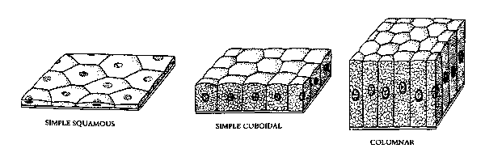
- ___________________________________________: Cells flattened like fish scales
- ___________________________________________: Cube-shaped (like dice)
- ___________________________________________: Shaped like columns
LAYERS
- ___________________________________: Only one layer
- ___________________________________: More than one layer
Simple Squamous Epithelium
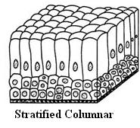
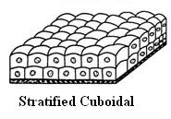
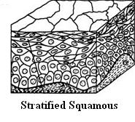
- Usually forms membranes where ___________________________________ or exchange of substances occur.
  - ___________________________ of lungs
  - Walls of capillaries
Simple Cuboidal Epithelium
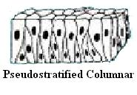
- Found in ___________________________ and ducts.
  - Salivary glands
  - Pancreas
- Forms the walls of the ______________________ and covers the surface of the ovaries.
Simple Columnar Epithelium
- Lines the entire length of the ____________________________________________from stomach to anus
- ___________________________________: Cells that produce mucus
- Goblet cells are found here.
Pseudostratified Columnar Epithelium
- Rest on the basement membrane.
- Some of its cells are ____________________ than others and their ________________________appear at different heights.
- Gives the false impression that it is ___________________________________.
- Main function is ___________________________________ and ___________________________________.
- Traps dust & debris. Cilia propels mucus up and out of lungs.
Glandular Epithelium
- Form 2 types of glands:
- ___________________________________ Glands: Secretes hormones directly into the bloodstream. Ex: Thyroid Gland secretes the hormone thyroxin directly into the bloodstream and is distributed throughout the body raising metabolism.
- ___________________________________ Glands: Secretes their substances into tubes which carry the secretions to the epithelial surface. Ex: Sweat, saliva, milk
Exocrine Glands are classified in two ways
- Structure
  - ___________________________________: One duct
  - ___________________________________: Several ducts
- Shape
  - ___________________________________: Long & slender
  - ___________________________________: Rounded
