Menstrual Cycle, Pregnancy, & Birth
Menstrual Cycle
- A series of ______________________________changes that help to prepare a woman’s body for pregnancy.
- ___________________________________: First female period that usually occurs around age 12.
- A cycle can range from 21-45 days, with ________________________ days being the average.
- Consists of 2 cycles:
  - __________________________________ Cycle
  - __________________________________ Cycle
Ovarian Cycle
- Involves changes in the ovaries
- Can be divided into 2 phases:
  - ____________________________________ Phase (Days 1-13)
    - First day of ________________________________ until ________________________________.
    - Egg growth/maturation is occurring in the ovaries.
  - ____________________________________ Phase (Days 14-28)
    - From _________________________________ until ______________________________begins.
Uterine Cycle
- Involves changes in the uterus.
- Occurs together with the Ovarian Cycle.
- Can be divided into 2 phases:
  - ____________________________________________ Phase (Days 5-14)
    - Occurs after ________________________________ but before ovulation
    - Endometrium rapidly grows in thickness
  - ____________________________________________ Phase (Days 14-28)
    - Occurs at _____________________________________ if fertilization does not occur.
    - Egg & __________________________________________ begin to break down.

Ovulation
- During the first half of the menstrual cycle, as many as 20 _____________________________________ begin to grow in the ovaries due to Follicle Stimulating Hormone (FSH).
- Half way through the cycle, there is a spike in the _____________________________________ Hormone (LH) which signals the release of the most __________________________________ egg from the ovary. This is referred to as _____________________________________.
- The remaining egg follicles undergo ___________________________________, or cell degeneration.
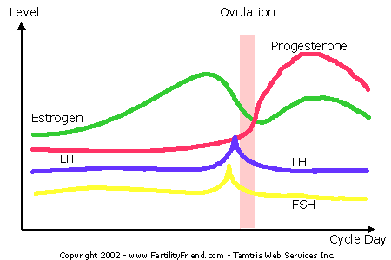
- If more than one egg follicle grows to maturity, they can also be released from ovary increasing the chance of ________________________________________ twins or triplets.

How Conception Occurs
- Fertilization occurs when a sperm and egg unite in the ________________________________, creating new life.
- The female egg can only be fertilized for _________________ hours after being released.
- An average 300 million sperm are released in one ejaculation, however only _______________________ will reach the uterus due to the harsh acidic environment of the vagina.
- Most sperm only survive for _________________ in the vagina with a maximum of about _____________ hours.
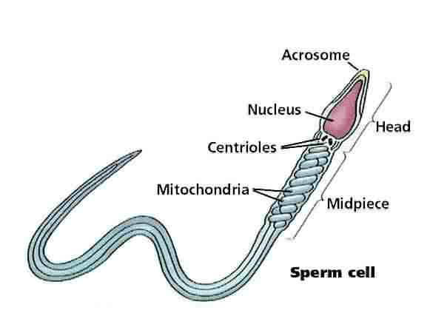
- This environment is necessary to deplete a fatty covering on the sperm that will then allow the sperm to fuse with the egg.
Sperm Anatomy

Sperm Physiology
- To fertilize an egg, sperm must undergo a 3-step modification process.
- ________________________________: Secretions in the female reproductive tract modify the sperm’s membrane to allow it to fertilize the egg.
- ________________________________: They become better, more efficient swimmers.
- ________________________________ Reaction: The acrosome creates an enzyme reaction with the egg’s zona pellucida, weakening it and allowing entry.
Fertilization
- Once a sperm(______________) has penetrated the egg (________), a chemical reaction takes place within the egg making it impossible for another sperm to enter.
- Almost immediately the nuclei of the sperm and egg fuse to produce a __________________________________ containing genetic material from both mother and father.
- The sex of the fetus is determined at this point.
  - If an __________sperm meets the X egg = ___________________________ (XX)
  - If a __________ sperm meets the X egg = ____________________________ (XY)
Implantation
- The fertilized egg will make its way to the uterus where it will ___________________________________.
- It takes roughly _________ days for the fertilized egg (blastocyst) to travel and implant.
- Occasionally a fertilized, dividing egg will attach to the lining of the fallopian tube. This is called an ________________________________________________
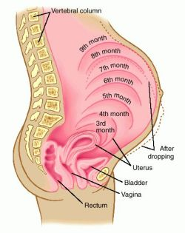
- This type of pregnancy must be terminated for the safety of the mother. The fallopian tube is not __________________________ and the growing blastocyst will _______________________________ the tube.
Pregnancy
- A typical pregnancy lasts approximately _________________weeks (280 days)
- These 40 weeks are broken up into _____________________________________:
  - 1st Trimester: Weeks __________________
  - 2nd Trimester: Weeks _________________
  - 3rd Trimester: Weeks _________________

Embryonic Development
- Fertilized egg is called an __________________________________ until _________ weeks after fertilization.
Fetal Development
- From weeks ________________, the baby is termed a __________________.
Birth (Parturition)
- 3 Stages
1. Shortening/dilation of ______________________
2. Descent/birth of __________________________
3. Delivery of _____________________________
- Labor Stage 1: Effacement & Dilation
  - As baby moves down, the cervix thins (________________________________).
    - Given as a _______________________________ (75% effaced).
  - Cervix begins to open (____________________________).
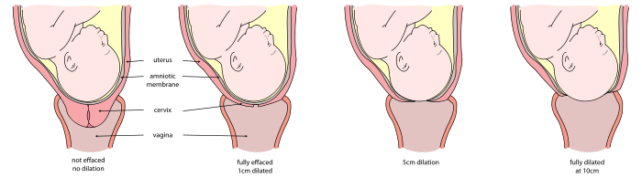
    - Assigned a number ______________________

- Labor Stage 2: Fetal Expulsion
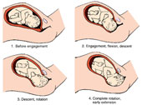
  - Cervix must be fully _____________________________ to _____________________.
  - Mother is pushing
  - Baby’s head is ___________________________________
  - Baby has large ___________________________ and _
________________________________ and must maneuver out in a s
pecific pattern of rotation:
- Labor Stage 3: Umbilical Cord Clamped & Placenta Expulsion
  - Typically the ____________________________________________ is clamped & cut in the first _____________ minutes of birth.
  - The __________________________________ is delivered ___________________ minutes after birth.

