Neuron, Brain, & Nervous System Webquest
http://tinyurl.com/2e4ynbm

- Make a Mad, Mad, Mad Neuron

Build your own monster neural circuit
1. Define the following structures used to make your mad neuron.
Cell body
Dendrites
Axon terminal
Nucleus
Myelin sheath
Axon

2. Draw and label your neural circuit

- Crossing the Divide: How Neurons Talk to Each Other

3. How do nerves communicate with one another?

4. What is inside a vesicle? Give one example.

5. What do the receptors do?

6. Why use a second messenger?

7. What does the second messenger do?

8. When is the impulse terminated?

- The Other Brain Cells

9. Identify the function of the different glia cells in the brain.
Oligodendrocytes
Microglia
Astrocytes

10. How can astrocytes help defend against disease?

- Label A Neuron & Label a Brain (MultiView)

A.
B.
C.
D.
E.
F.
G.
H.
I.
J.
K.
L.
M.
N.
O.
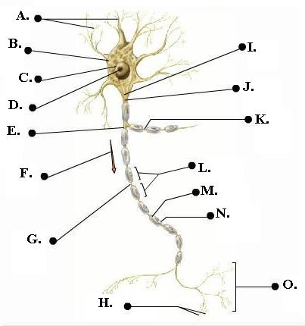

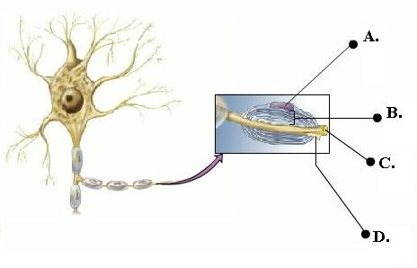
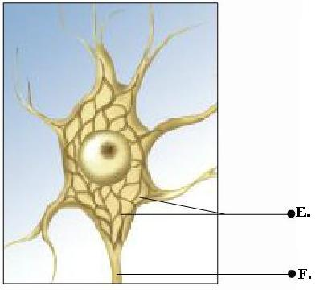
A.
B.
C.
D.
E.
F.
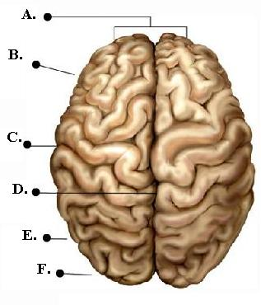
A.
B.
C.
D.
E.
F.
G.
H.
I.
J.
K.
L.
M.
N.
O.
P.
Q.
R.
S.
T.
U.
V.
W.
X.
Y.
Z.
AA.
BB.
CC.
DD.
EE.
FF.
GG.
HH.
II.
JJ.
KK.
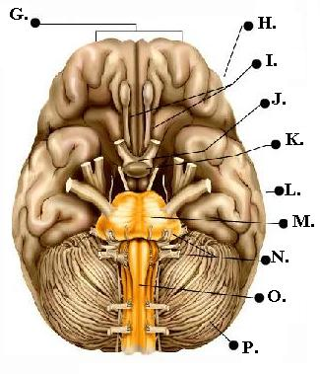
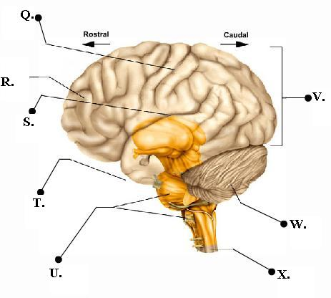
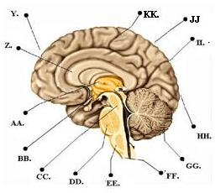

- Neuron Animation Video Questions:

12. Label the charges (inside and outside) of a neuron at rest on the diagram below:
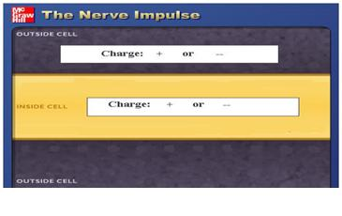

13. When a neuron is stimulated, in what direction does Na+ move?
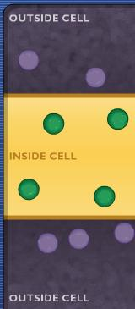

14. In what direction does K+ move?

15. Label the ions (circles) on the diagram to the right AND
draw arrows showing the direction of ion movement.

Resting & Action Potential
16. So what effect will the voltage difference have on the Na+ ions when the Na+ channels first open? A B C D
17. Explain why that answer is correct:

18. At the end of the depolarization phase, what is the tendency for movement of a sodium ion at the mouth of a sodium channel?
- The sodium ion will still be pulled in most of the time.
- The sodium ion will stay outside most of the time.
- Explain why that answer is correct:

Quiz Questions: (Please answer with a number: 1 for 1st answer, 2 for 2nd, etc…)
1.________ Which side of the axon is more positive before the action potential?
2._______ What causes diffusion?
3._______ Which pair of charges will attract each other?
4._______ If the inside of the neurons is -30mV relative to the outside, the K+ ion channel is open, what will the K+ ion tend to do?

F: Nervous System Game: You will get 10 body parts from a random mix. In the table, write the name of the body part, then tell how the nerve impulse travels and what section of the spinal cord the nerve connects.
BODY PART | HOW THE NERVE IMPULSE TRAVELS | SPINAL CORD CONNECTION
1.
2.
3.
4.
5.
6.
7
8.
9.
10.

F: The Human Brain Map:
CEREBRUM
Describe what the cerebrum looks like:
What is the cerebral cortex?
Name the 4 lobes that make up the cerebral hemispheres | 1.  2.  3.  4.
**Right & Left Hemispheres**
What joins the left & right hemispheres?
Explain how someone with damage to the left hemisphere of the brain would act in comparison to someone with damage to the right hemisphere.
**Frontal Lobe**
Where is the frontal lobe located and what can be said for its size?
Provide three functions of the frontal lobe. | 1.  2.  3.
What does the motor cortex do?
**Cerebral Cortex**
What do the nerves of the cerebral cortex do?
**Motor Cortex**
Where is the motor cortex located?
What is the function of the motor cortex?
Name 3 places to which the motor cortex provides fine motor skills. | 1.  2.  3.
Describe what often happens when damage occurs to the Broca’s area.
**Sensory Cortex**
In which lobe of the brain do you find the sensory cortex?
Name 3 places on the body that contain the most sensory receptors. | 1.  2.  3.
**Parietal Lobe**
Provide 4 examples of tasks carried out in the parietal lobe of the brain. | 1.  2.  3.  4.
**Temporal Lobe**
Provide 2 examples of tasks carried out in the temporal lobe of the brain. | 1.  2.
Describe the effect of brain damage done to the Wernicke’s area.
**Occipital Lobe**
What is the function of the occipital lobe?
LIMBIC SYSTEM
What is the function of the limbic system?
What is another name for the limbic system?
**Olfactory Bulbs**
What is the function of the olfactory bulbs?
**Hypothalamus**
What conditions within the body are kept constant by the hypothalamus?

**Thalamus**
Why is the thalamus so essential to our well being?
**Pineal Gland**
What hormone is secreted by the pineal gland? What does it do?
**Hippocampus**
What are 2 functions of the hippocampus? | 1.  2.
**Amygdale**
What is the job of the amygdala?
**Pituitary Gland**
Why is the pituitary gland referred to as the master gland? Give examples.
BRAIN STEM
What are 5 jobs of the brain stem? | 1.  2.  3.  4.  5.
**Midbrain**
What 2 reflex centers are found in the midbrain? | 1.  2.
**Pons**
The pons serves as a relay station between what 2 structures?
The pons regulates what essential function?
**Medulla Oblongata**
The medulla oblongata serves as a relay station between what 2 structures?

The medulla oblongata is responsible for what 5 actions? | 1.  2.  3.  4.  5.
**Cerebellum**
What is the cerebellum responsible for coordinating?
If there is extra time….
- Neuron Jigsaw Puzzle
- What Sex Is Your Brain?
- Face Memory Test
- I.Q. Test
- Left or Right Brained?

