Organization of the Nervous System
- The nervous system is the master ____________________________ and _____________________________ system of the body.
- The nervous system has 3 main functions:
  - Uses ____________________________________ to monitor changes inside and outside of the body. (_____________________________________)
  - ________________________________: Processes and interprets sensory input and makes decision.
  - ______________________________________: Responds by muscles or glands.
(_____________________________________)
Organization of the Nervous System
- _____________________________________________ Nervous System (CNS):
  - _________________________ and _______________________________
  - Command center
  - _______________________________ incoming sensory information
  - Make decisions based on ______________________________________________.
- _____________________________________________ Nervous System (PNS):
  - ______________________________ that extend from the brain and spinal cord.
  - Sensory (________________________________) Division:
    - Deliver impulses _____________________________________ from various parts of the body.
  - Motor (________________________________) Division:
    - Carries impulses _____________________________________ to muscles and glands.
Neuron
- Dendrites______________________ the _________________________ for receiving incoming information.
- Axon: Carries information from the _____________________________ to a neighboring neuron.
- Myelin Sheath: Insulating ________________________ that increase the rate of signal transmissions
- Node of Ranvier: __________________ axon; allows ____________________________________ to jump from node to node.
- Axon Terminals: Release chemicals called _________________________________________.

Supporting Cells: CNS
- 6 Cell Types Total: 4 CNS; 2 PNS
- ______________________________________: ____________________________________ microorganisms that could be harmful to the CNS. A type of macrophage.
- Astrocytes: Most abundant; _________________________________ the neurons in place by attaching to _____________________________. Also serve as a ________________________(blood supply) to neurons.
- Ependymal Cell: Line the brain & spinal cord ________________________(dorsal). Have _______________ that help to circulate the cerebro-spinal fluid.
- Oligodendrocytes: _________________________ axons of neurons to form __________________ sheaths.
Supporting Cells: PNS
- Schwann Cells: Help form _______________________________________; also engulf deteriorating cell debris & aid in __________________________________.
- Satellite Cells: Surround the _______________________________ and regulate chemical environment.
Resting Potential
- A neuron sends messages ________________________________________.
- Ions are _________________ & ______________ (positive)
- A neuron is at rest when it is not sending a signal and is in a ___________________________ charged state.
- Even at rest, the neuron allows __________ to pass.
- Neuron pumps ____________ Na ions out for every ___________ K ions it pumps in.
- At rest, there are more ____________ ions ___________________________ and more __________ ions ______________________________.
Action Potential
- Occurs when a neuron sends ____________________________ down the ____________________.
- Electrical activity created by a ___________________________________ current.
- A ______________________________ must make the neuron reach its _____________________________ in order to fire an action potential.
- Stimulus causes _________ channels to open and Na+ rushes ________________the neuron, depolarizing it.
- ___________ rushes out of the cell, ___________________________ the depolarization.

Autonomic Nervous System
- Part of the PNS.
- Has 2 divisions: _________________________________ & _____________________________________.
- Controls ____________________________, digestion, respiration rate, salivation, & perspiration.
Sympathetic
- Neurons begin in the ________________________ & _______________________ region of the spinal cord
- Functions in actions that require a _____________________ response.
- “__________________________________________” response.
Parasympathetic
- Neurons begin in the _______________________ & ______________________ regions of the spinal cord.
- Functions in actions that do not require an immediate _________________________.
- “_________________________________________”
- Constant _______________________________________ to Sympathetic N.S.
Reflexes
- _______________________________, rapid actions; usually for survival.
- Most reflexes don’t have to travel to the _________________________, as they need to happen quickly.
  - _____________________________________:
    - Receptors are ________________________________.
    - Signal travels along ____________________________ neuron to _______________________.
    - Signal is passed onto a ___________________________________.
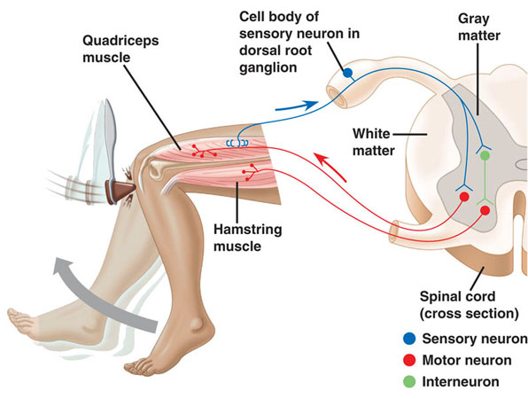
    - _______________________________________ is stimulated.

