Respiratory System
- Respiratory System Includes…
- Nose, pharynx, larynx, trachea, bronchi, & lungs
  - Nose: ______________________________; oxygen enters the body.
  - Pharynx: Serves as a passageway for ______________________ AND ________________. (Throat)
  - Larynx: ____________________________
  - Trachea: ____________________________; Leads oxygen to lungs.
  - Bronchi: Division of the ______________________________; Attaches to lungs.
  - Lungs: Large respiratory organs; Run from the ______________________ to the ____________________
  - Alveoli: _________________________ in the lungs.
- External Respiration
  - External Respiration: External air is drawn into the ______________________ to supply oxygen and used air is expelled from the lungs to remove _________________.
- Internal Respiration
  - Gas exchange between ____________________________ & ___________________________ (CO2 is removed from blood & replaced with O2).
- Mechanics of Breathing
  - _______________________________: Air flow into the lungs (inhaling)
  - _______________________________: Air leaving the lungs (exhaling)
- Inspiration
  - Intercostal muscles ________________________________
  - ______________________________________ moves upward & outwards
  - Diaphragm ________________________________
  - ___________________________________ volume of the thoracic cavity
- Expiration
  - Intercostal muscles ____________________________
  - ______________________________________ move downward & inward.
  - Diaphragm ____________________________ forming a bell shape.
  - Volume in thoracic __________________________________.
- Respiratory Volume & Capacity
  - ___________________________________Volume: The amount of oxygen taken in with a regular breath. (Sitting in class)
  - _____________________________________________ Volume: Oxygen that can be taken in forcibly over the tidal volume. (Before blowing up balloon)
  - _____________________________________________ Volume: The amount of oxygen that can be forcibly exhaled after a tidal expiration. (While blowing up balloon)
  - _____________________________________________: Total amount of exchangeable oxygen.
TV + IRV + ERV = VC
- Voice Production
  - Relies on:
    - ______________________________________
    - ______________________________________
    - ______________________________________
  - When we speak we place more emphasis on our inhalation muscles and speak long on our exhaled air.
  - Too much pressure or too little pressure can cause the voice to sound strained.
- Disorders
  - _______________________________: Alveoli enlarge and lungs lose their elasticity. Difficult to exhale.
  - _______________________________: Respiratory passages fill with excessive amounts of mucus.
  - _______________________________: Cancer usually caused by smoking.
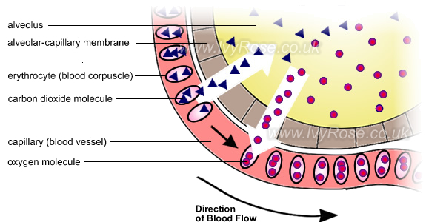
  - _______________________________: Difficulty breathing usually caused by allergies, exercise, or anxiety.

