Skeletal System Online Test Review
http://tinyurl.com/oxucxuo Name: ________________________________________
http://msjensen.cehd.umn.edu/webanatomy/skeletal/bone_terms_1.html
Bone Terminology: Bone Terms I & Bone Terms II
Description | Part of Bone | Word Bank
- An opening through a bone, which usually serves as a passageway for blood vessels, nerves, or ligaments. |  | - Condyle  - Epicondyle  - Foramen  - Fossa  - Fovea  - Head  - Meatus  - Process  - Sinus  - Spine  - Suture  - Trochanter  - Tubercle  - Tuberosity
- A projection situated above a condyle.
- A relatively deep pit or depression.
- A rounded process that usually articulates with another bone.
- A tube like passageway within a bone.
- A thorn like projection.
- A small knob like process.
- A prominent projection on a bone.
- A cavity within a bone.
- A tiny pit or depression.
- An interlocking line of union between bones.
- An enlargement of the end of a bone.
- A relatively large process.
- A knob like process usually larger than a tubercle.

Watch the video on Bone Formation:
http://www.neok12.com/php/watch.php?v=zX4b7e7c015e414f645c4206&t=Skeletal-System
Use the information in the video to describe the role of each of the following:
Bone Cell | What is it and what does it do?
Osteocyte

Osteoblast

Osteoclast

http://www.wiley.com/college/apcentral/anatomydrill/t06/at0603_1.htm

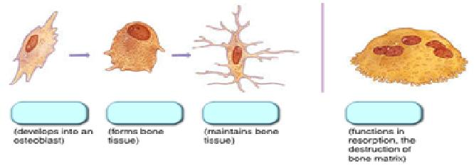

Joints:
http://www.bbc.co.uk/schools/gcsebitesize/pe/appliedanatomy/skeleton/2_anatomy_skeleton_act.shtml
- Most joints in the body are _________________________ or _______________________ joints.
  - Name 3 examples of this type of joint in the body:

- Which joint is the most mobile in the body?___________________
- Describe the movements of each below:
Movement | Description
Flexion
Extension
Rotation
Abduction
Adduction
Circumduction
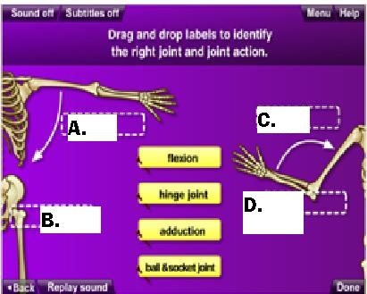
- Using the word bank, correctly fill in the diagram to the right:
Label | Type of Joint/Movement
A

B

C

D

http://www.bbc.co.uk/science/humanbody/body/factfiles/joints/gliding_joint.shtml
- Click on each of the following joint types and illustrate them
(Click on “controls” in the illustration box and show how they move)

Type | Illustration: | Description
MOVEABLE
Gliding

Ball & Socket

Hinge

Pivot

Saddle

Condyloid (Ellipsoidal)

SLIGHTLY MOVEABLE
Ex.=

FIXED
Ex.=

Bone Structure
http://www.wiley.com/college/apcentral/anatomydrill/t06/at0602_1.htm
Put the letter from the word bank in the correct bubble below.
Word Bank
- Articular Cartilage
- Compact Bone
- Diaphysis
- Distal Epiphysis
- Medullary Cavity
- Metaphysis
- Proximal Epiphysis
- Spongy Bone
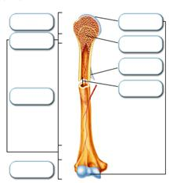

Compact Bone Diagram
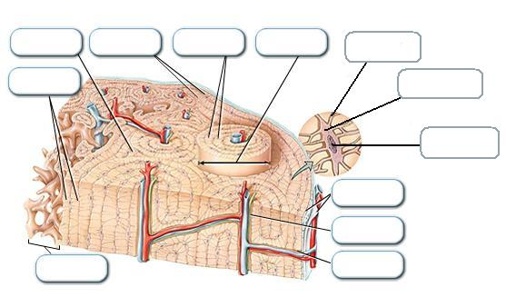
http://www.wiley.com/college/apcentral/anatomydrill/t06/at0604_1.htm
Put the letter from the word bank in the correct bubble below.

Word Bank
- Canaliculi
- Central (Haversian) Canal
- Concentric Lamellae
- Inner Circumferencial Lamellae
- Interstitial Lamellae
- Lacunae
- Osteocyte
- Osteon
- Outer Circumferencial Lamellae
- Perforating (Volkmann’s) Canal
- Periosteum
- Spongy Bone (Trabeculae)

