DOC022812-007.tif

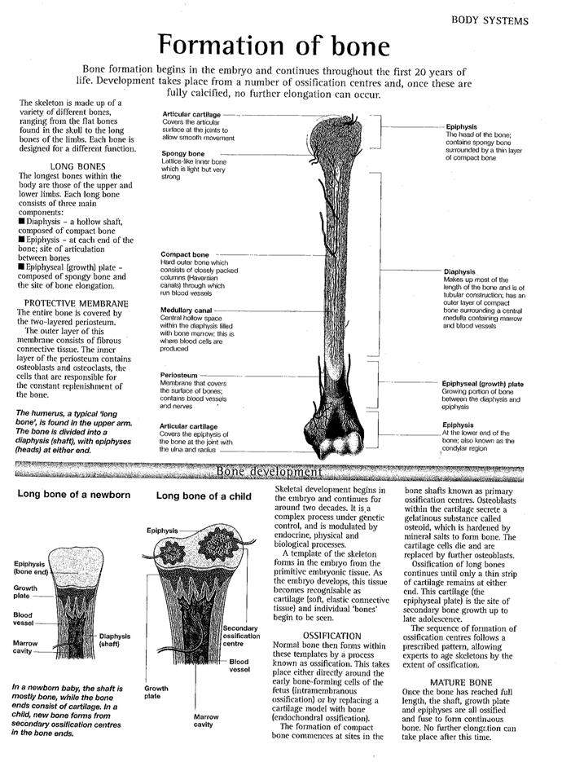

DOC022812-009.tif

DOC022812-010.tif