Special Senses
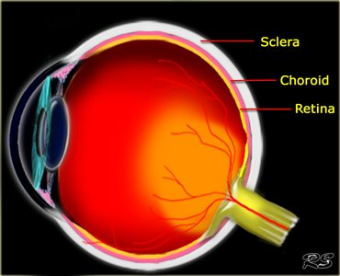
The Eye: Sense of Sight
- 3 Layers (Tunics)
  - ___________________________________: Outer Tunic
  - ___________________________________: Middle Tunic
  - ___________________________________: Inner Tunic
- Sclera
  - ________________________________, protective, fibrous covering
  - “____________________________ of the eye”
  - Insertion point for __________________________________ attachment that move & control eye.
  - Extends from the ___________________________ (front) to the ______________________________ (back)
  - Cornea: Transparent “____________________________” in the front of the eye that covers the pupil & iris and aids in light refraction.
- Choroid
  - Layer of blood _____________________________ & _______________________________ tissue.
  - Supplies ___________________________________ to the inner eye.
  - _____________________: Pigmented, circular muscle controls the size of the pupil, letting more or less light in.
  - ______________________: Black opening in the center of the pupil that allows light to enter.
  - ______________________: Works with the cornea to reflect light and focus on the retina.
- Retina
  - _____________________________________________ tissue that lines the inner eye.
  - Photoreceptors:
    - ________________________: Small photoreceptors that allow for black & white vision and in low levels of light.
    - ________________________: Large photoreceptors that allow for color vision.
  - ___________________________________: Small yellowish central part of the retina.
  - Provides clearest, most distinct vision (reading)
  - _______________________________________
    - Center of the macula
    - All ____________________________, no _________________________
    - The sharpest vision

    - Blind Spot
    - Where the ___________________________ meets the __________________________.
    - No ________________ or ______________________.
Chambers of the Eye
- ______________________________ Humor
    - ___________________________ cushion
    - Between the cornea & iris (______________________________ Chamber)
    - Between the iris & lens (_____________________________Chamber)
- _______________________________Humor
    - ____________________________ cushion
    - Between the lens & retina.
Diseases of the Eye
- __________________________________:
    - _________________-Sightedness (Can’t see distance)
    - Eyeball is too _______________________causing light to focus _______________________ the retina.
    - PRK or Lasik: removes corneal tissue to allow light to focus on the retina.
- __________________________________:
    - ________________-Sightedness (Can’t focus on close objects)
    - Eyeball is too _______________________ causing light to focus _______________________ the retina.
    - Lasik or CK: tightens & steepens the cornea adding depth and allowing light to focus on the retina.
- _____________________________________:
    - Eye condition caused by ____________________________ from the Aqueous Humor causing damage to the ________________________, leading to blindness.
- ____________________________________:
    - ______________________ Eye
    - Inflammation of the conjunctiva (clear membrane covering the sclera) causing blood vessels to dilate.
    - ______________________________: From bacteria or virus
    - ______________________________: Irritants such as dust, debris, smoke.

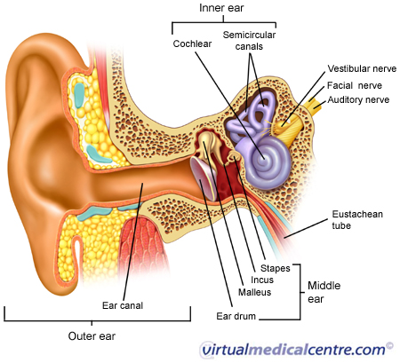
The Ear: Sense of Hearing
- Outer Ear
- Middle Ear
- Inner Ear
- Outer & Middle ear function in ___________________________________ ONLY.
- Inner ear functions in ____________________________ AND ______________________________/equilibrium.
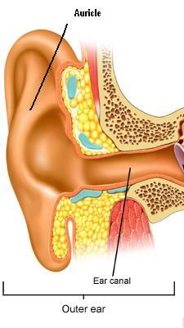
Outer Ear
- ___________________________________________:
    - External Ear; “Shell-shaped”
    - Collects _________________________________________________.
- External _____________________________________Canal:
    - Air-filled, 1” S-Shaped Canal
    - Secretes ________________________________
    - Channels sound waves to ____________________________________.
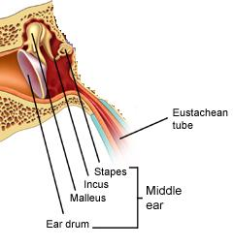
Middle Ear
- ________________________________________________:
    - Ear Drum
    - Divides the outer & middle ear
    - Sound waves cause it to __________________________________.
- Auditory ______________________________________:
    - _________________________________: Hammer/mallet shaped
    - _________________________________: Anvil shaped
    - _________________________________: Stirrup shaped
- Eustachian Tube
    - Connects __________________________ ear to back of _________________________ cavity
    - _________________________________, except for yawning/swallowing
    - Equalizes air ______________________ and allows ______________________ of middle ear secretions.

Inner Ear
- __________________________ Window
    - Membrane that connects ___________________ ear with ___________________ portion of cochlea.
- __________________________ Window
    - Membrane that connects ___________________ ear with ___________________ portion of cochlea.
    - Moves fluids & equalizes pressure.
- Cochlea
    - _____________________-shaped, ____________________ filled bone.
    - Converts _________________________from environment into _______________ impulses for the brain
- Semicircular Canals
    - 3 loops filled with watery fluid embedded in the ____________________________bone.
    - Aids in _____________________________ only, not hearing.
Disorders of the Ear
- Ear Infections
    - Common in infants & children
    - ________________________invade the middle ear near auditory _________________________.
    - Cause build up of ____________________ & painful ____________________________________.
- Deafness
    - Can be ____________________________________or developmental
    - ________________________________________: Impairment in the outer or middle ear.
    - ________________________________________: Impairment in the inner ear.
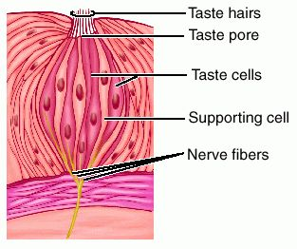
The Tongue: Sense of Taste
- __________________________________________
    - ________________________________; “nipples”
    - Found on the tongue, cheeks, & roof of mouth
    - 10,000 taste buds with 100 taste cells (Gustatory Cells)
    - __________________________________________ send taste impulses to the brain.
    - Taste buds have an opening at the end called a _________________________________.

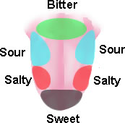
- Taste Sensations

The Nose: The Sense of Smell
- ______________________________________are located on the olfactory epithelium.
- Odor molecules dissolve in _______________________& bind to receptors on the ___________________.
- Cilia are connected _________________________________.
- Smell receptors bind to the __________________________________________.
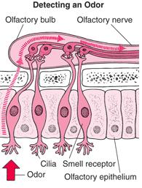
- Olfactory nerves transmit the ________________________ to the ________________________.
