The Digestive System
Functions
- __________________________________
- Absorption
- __________________________________
2 Types of Digestion
- ___________________________________
  - Begins immediately after __________________________________
  - __________________________________ (chewing) with teeth
  - Purpose is to break down food into smaller pieces
  - __________________________________: Squeezing of food down the esophagus
2. __________________________________
  - Accomplished by digestive __________________________________
  - Enzymes break down ________________________ molecules (Fats, Carbohydrates, & Proteins)
Enzymes
- __________________________________: Breaks down protein
- __________________________________: Breaks down fat
- __________________________________: Breaks down carbohydrates (starches down to sugars
Alimentary Canal
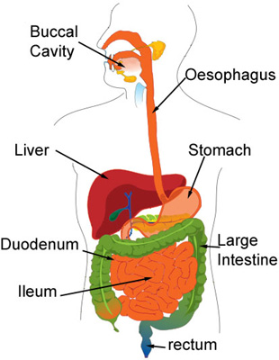
- Canal connecting ________________________ to _______________________.
  - Mouth
  - Pharynx
  - __________________________________
  - Stomach
  - __________________________________
  - Large Intestines
  - __________________________________
  - Rectum
  - __________________________________
Mouth
- __________________________________: Roof of mouth (front)
- __________________________________: Roof of mouth (back)
- Uvula: Fleshy flap that keeps food from moving up into your __________________________________when swallowed.
- Epiglottis: Elastic cartilage attached to root of tongue that directs air into the trachea ____________________________ and food into the __________________________________.
- Tongue : Moves food around and allows for _____________________________.
- __________________________________: Used to break down food into smaller pieces.
Coats
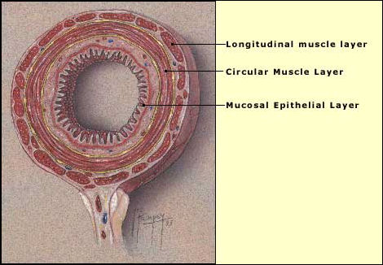
- Beginning with the pharynx to the anus, the walls of the alimentary canal are composed of two coats:
  - __________________________________
    - Epithelial Goblet cells line the canal producing mucus.
  - __________________________________
    - Inner muscles: __________________________________
    - Outer muscles: __________________________________
- Both coats facilitate ____________________________________________________________________.
Pharynx
- Throat
- ____________________________________________________________________ all mix here.
Esophagus
- Connects the __________________________________ to the __________________________________
- Pushes food down by __________________________________.
- ________________________: Chewed food
Stomach
- “C-shaped” organ that contains ______________________ to break down food.
- Food mixes with stomach acid to produce a thick cream called ___________________________.

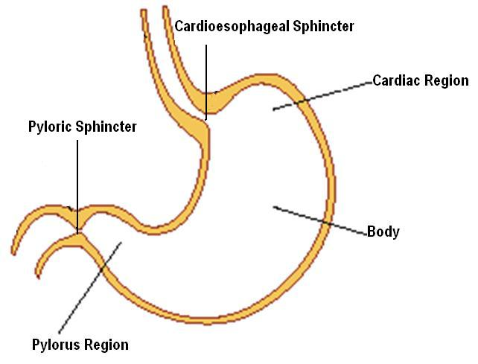
- Has 3 Regions:
  - __________________________________: Upper stomach region
  - _______________________: Mid stomach region
  - __________________________________: End stomach region
- __________________________________: Muscular valves that control opening & closing.
  - __________________________________Sphincter: Valve connecting the esophagus to the stomach.
  - __________________________________Sphincter: Valve connecting the pylorus to the small intestines.
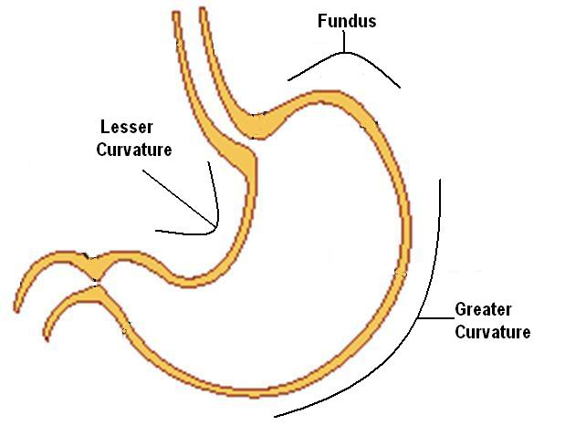
- Curvatures:
  - __________________________________
  - ____________________________ Curvature
  - ____________________________ Curvature
- __________________________________: Internal stomach wrinkles
  - Fewer rugae when ___________________
  - More rugae when ____________________
Small Intestine
- Main function is ____________________________________________________________________
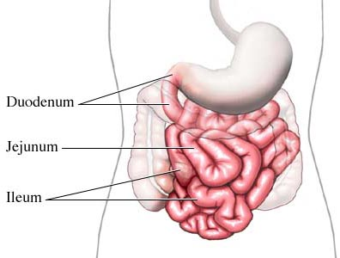
- Has 3 divisions:
  - __________________________________
  - Jejunum
  - Ileum
- Duodenum
  - _____________________ segment of the small intestine
  - Connects to __________________________.
  - Receives chyme from stomach
  - Regulates gastric emptying
  - Continues digestion
  - Signals __________________________________
  - Stimulates the liver, gall bladder, & pancreas
  - In gastric bypass surgery, the duodenum is usually bypassed.
- _________________________________________
  - _________________________segment of the small intestine
  - Finalizes food digestion
- Ileum
  - ___________________________& final segment of the small intestine
  - Main function is to absorb nutrients
  - Returns _____________________ back to liver
  - Connects to the large intestine by the _________________________________ valve
Large Intestine
- __________________________ waste is passed from the small intestine to large intestine.
- Main function is to absorb any ___________________ or ________________________ from the waste.
- Compresses waste into compact form for easy removal from the body.
- Chyme combines with _______________________ and _________________________ and is converted to feces.
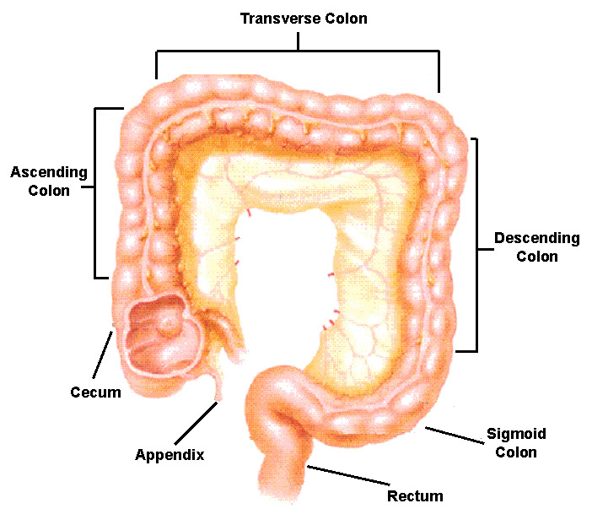
- v4 divisions:
1. Cecum
2. _____________________
3. Rectum
4. ______________________
- Cecum
  - _________________ segment of large intestine.
  - Connection at the small intestine at ileocecal valve.
- Colon
  - 4 segments named for their relation to the pelvis:
1. __________________________________ colon
2. __________________________________ colon
3. __________________________________ colon
4. __________________________________ colon

- Rectum
  - Collects _________________________ accumulated in the colon.
- Anal Canal
  - _________________________tube (1.5”)
  - 2 muscular rings
    - _______________________________(Internal muscle)
    - _______________________________ (External muscle)
These muscles relax to allow for __________________________________.

