Unit 2 Test Review:
Medical Technologies & Tissues

Match the medical technologies:  Xray  CT Scan  MRI  Ultrasound  EEG | a. High energy radiation can penetrate tissues and strike a photographic plate.  b. Surrounds the body with a magnetic field, then sends radio waves to sense pulses from soft tissues.  c. Measures small electrical currents from neurons inside the brain.  d. Uses X-rays that rotate around the body and easily shows soft tissues.  e. Sound waves are transmitted directly through skin and echoes are detected and mapped. |  |  |  |  |  |  | What is radiodensity?  Put the following in order from low to high radiodensity:  (blood, liver, bone, air, fat, muscle)
Explain the difference between the 3 types of junctions for cells and give an example for each. |  |  |  |  |  |  |  | Name 4 functions of epithelial tissue:  1.  2.  3.  4.
Draw a simple squamous epithelial tissue: |  |  |  |  | Draw a stratified cuboidal epithelial tissue: |  |  | Draw a pseudostratified columnar epithelial tissue:
What are goblet cells? |  |  |  |  | How do endocrine & exocrine glands differ from each other?
What are goblet cells? |  |  |  |  | Draw a compound tubular exocrine gland: |  |  | Draw a simple acinar exocrine gland:
Match the epithelial tissue to its location in the body: |  |  |  |  |  |  | Name the 5 types of connective tissue:
Simple Squamous  Simple Cuboidal  Simple Columnar  Pseudostratified Columnar |  |  |  | a. Lines digestive tract  b. Lines respiratory tract  c. Ducts & glands  d. Airsacs of lungs
What is the main function of connective tissue? (one word) |  |  |  |  | What is another name for bone? |  |  | What is the function of areolar tissue?
What are the 3 types of cartilage?  Tell where each is found:  1.  2.  3. |  |  |  |  | How are tendons different than ligaments? |  |  | What 2 functions does adipose tissue serve?
Where in the body do we find reticular tissue? |  |  |  |  | What is the main function of muscle tissue? (one word) |  |  | Define peristalsis.
Match the muscle tissue to its description:  Skeletal  Cardiac  Smooth |  |  | A. Nonstriated & involuntary  B. Striated & voluntary  C. Striated & involuntary |  |  |  |  | What are intercalated discs?
Identify the tissues:  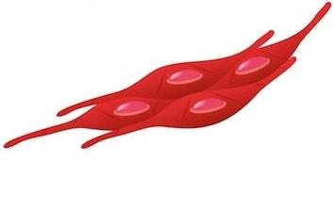  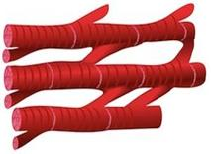  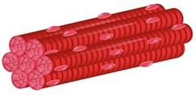  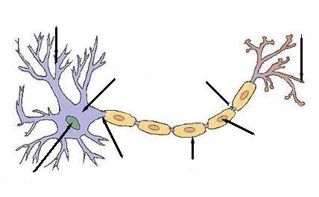 |  |  |  |  |  | Label the neuron:
What is the main function of nervous tissue? (one word) |  | Compare fibrosis to regeneration.

