Unit #3 Review Sheet
1. What material did Hooke look at under a microscope? What did he name them?  Looked at:  Named them: | 2. What are the 3 parts to the cell theory?  1. All living…  2. Cells are the…  3. All cells come… |  |  |  |  |  |  |  |  | 3. Living things are “organized”. List the level of organization from most simple to complex.  Cells(A.)Organs(B.)(C.)  A.)  B.)  C.)
4. Label the microscope diagram using the word bank.  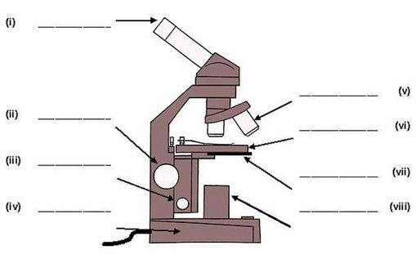  Word Bank  - Light Source b.) Eyepiece c.) Base  d.) Stage e.) Nosepiece f.) Diaphragm  g.) Stage Clips h.) Coarse Adjustment Knob  i.) Objective Lenses j.) Fine Adjustment Knob |  |  |  |  |  |  |  | 5. Match the function with the word bank.  ________ Controls the amount of light.  ________ Focuses while using low power.  ________ Focuses while using medium &  high power.  ________ Raises and lowers the stage.  -----------------------------------------------------------  6. Answer the magnification questions below.  ________ Magnification under low power.  ________ Magnification under medium power.  ________ Magnification under high power.  ________ Total magnification while using a  medium power objective.
7. Name each of the three cells pictured below:
A. B. C.
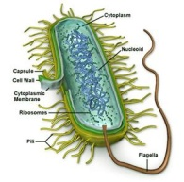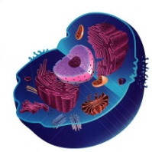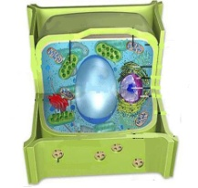

8. How is a prokaryote different than a eukaryote? |  |  |  |  |  | 9. Which of the pictures in question 7 is a prokaryote?  Which of the pictures in question 7 are eukaryotes? |  |  |  |  |  | 10. List 3 ways that plants cells are different than animal cells.  1.  2.  3.
11. Label the Cells Using the Word Bank
Word Bank
1. Cell Membrane
2. Smooth ER
3. Nucleolus
4. Rough ER
5. Lysosome
6. Chromatin
7. Mitochondria
8. Ribosomes
9. Vacuole
10. Cytoplasm
11. Centrioles
12. Cell Wall
13. Golgi Bodies
14. Chloroplasts
15. Nucleus

Function
_____ Powers the cell.
_____ Package & ship protein
_____ Water & nutrient storage.
_____ Produces ribosomes
_____ Fluid of the cell
_____ Makes protein
_____ Transports protein & has
ribosomes attached
_____ Digestive enzymes that break
down cell waste.
_____ Thin threads of chromosomes.
_____ Controls what enters & leaves
a cell.
_____ Regulates cell activities
_____ Transports protein & has no
ribosomes attach
_____ Site of photosynthesis
_____ Helps cell divide
_____ Rigid structure that offers
support & protection

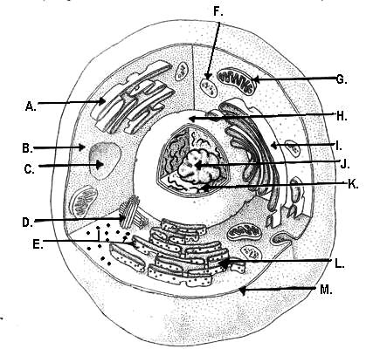
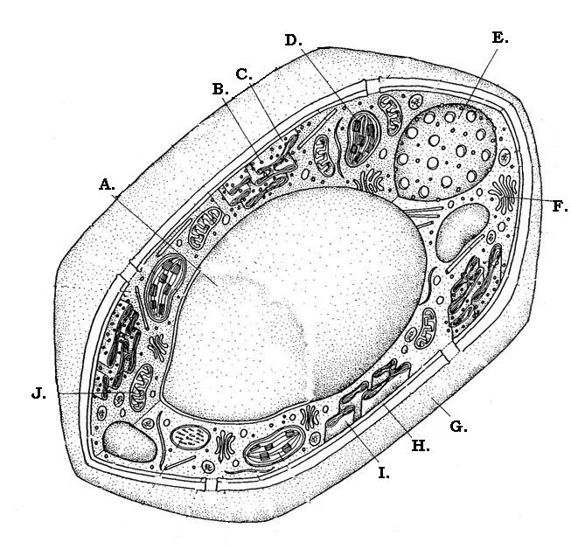 |  |  |  |  |  |  |  |  |  | 12. True or False:  ________The Cell Membrane and the Plasma Membrane are the same structure.
13. What term means that the cell is picky about what enters and leaves? |  |  |  |  | 14. How many layers thick is the Plasma membrane? |  |  |  | 15. What are the 2 components that make up the Cell Membrane?  1.  2.
16. Define the terms hydrophilic and hydrophobic.  Hydrophilic:  Hydrophobic: |  |  |  |  | 17. Define the terms polar and nonpolar.  Polar:  Nonpolar:
18. What term means that the cell is in “balance”? Explain how this term relates to the Cell Membrane. |  |  |  |  | 19. Define dynamic equilibrium.
20.  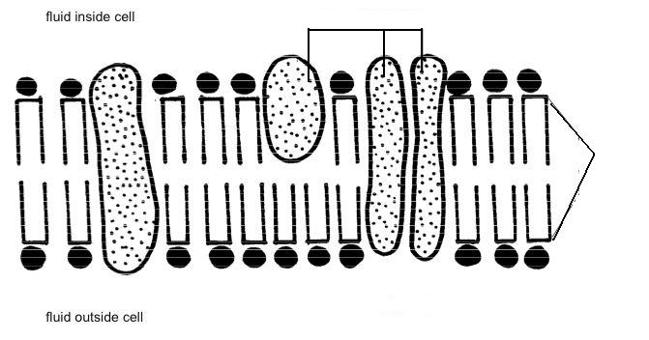 |  |  |  |  | Label the Plasma Membrane using the following terms:  Protein, Phospholipid, Polar, Nonpolar, Hydrophilic, Hydrophobic
21. How is Passive Transport different than Active Transport? |  |  |  | 22. Give 3 examples of Passive Transport:  1.  2.  3. |  |  |  |  |  |  |  |  | 23. Define osmosis.
24. Define concentration gradient: |  |  |  | 25. Explain how water moves in regards to the cell in each of the following solutions. Label each cell picture as hypertonic, hypotonic, & isotonic.  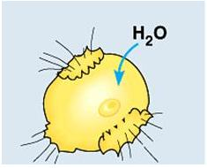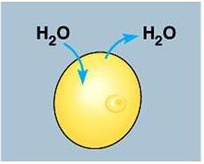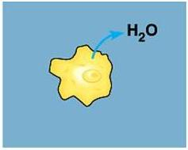
26. How does water move in each of these solutions? Label each as hypotonic, Isotonic, or hypertonic.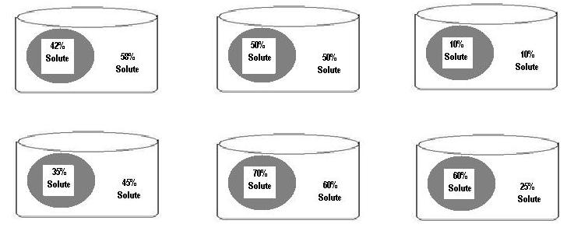
27. Draw ATP |  |  | 28. Draw ADP |  |  |  |  |  |  |  | 29. Where is energy stored in an ATP molecule?
30. Write the equation for cellular respiration using words |  |  |  |  |  |  | Write the equation for cellular respiration using molecules.
31. Write the equation for photosynthesis using words. |  |  |  |  |  |  | Write the equation for photosynthesis using molecules
32. List the reactants of cellular respiration. |  | 33. List the products of cellular respiration. |  |  |  |  | 34. List the reactants of photosynthesis. |  |  |  |  |  |  | 35. List the products of photosynthesis.
36. In what organelle does cellular respiration occur in? |  |  |  |  |  |  | 37. In what organelle does photosynthesis occur in?
38. What is the Cell Cycle? |  |  |  |  |  |  | 39. What are the 2 phases that make up the cell cycle?
40. What are the 3 divisions of interphase and describe what the cell is doing in each of the 3 phases: |  |  |  |  |  |  | 41. What are the 4 divisions of Mitosis listed in the order in which they occur?
42. Label the following stages of the cell cycle and put them in the correct order:
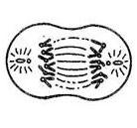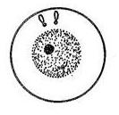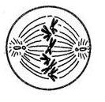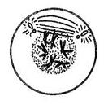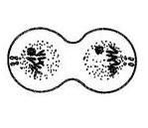
43. What are stem cells? |  |  |  |  |  |  | 44. How are embryonic stem cells different than adult stem cells?
45. Give examples of specialized cells in the body:

