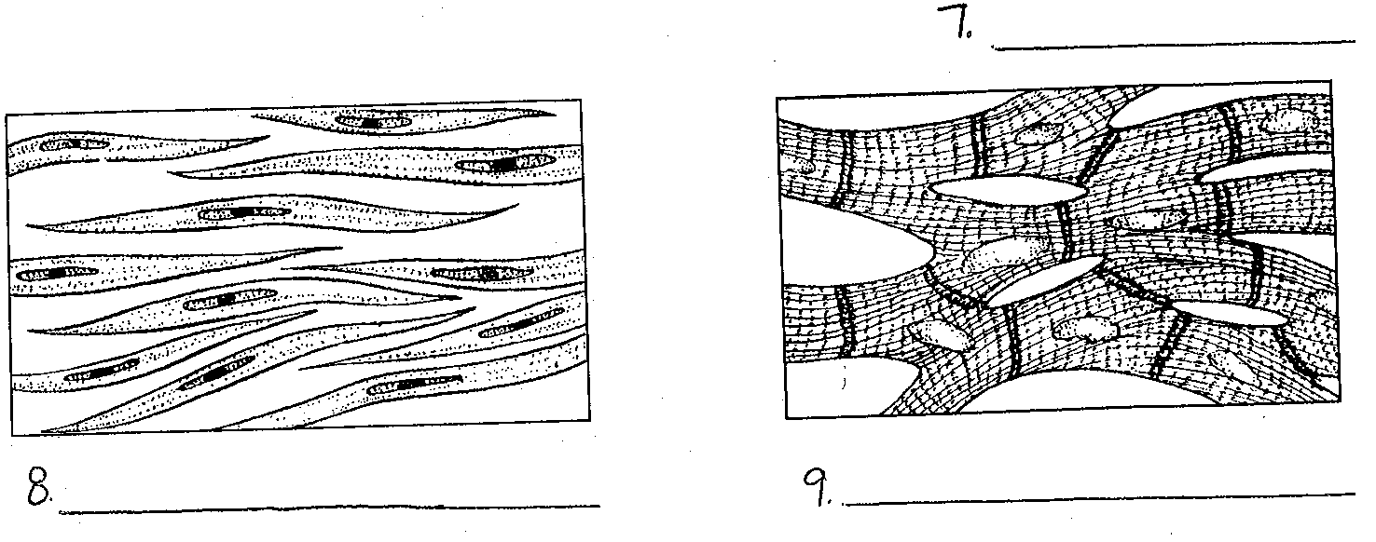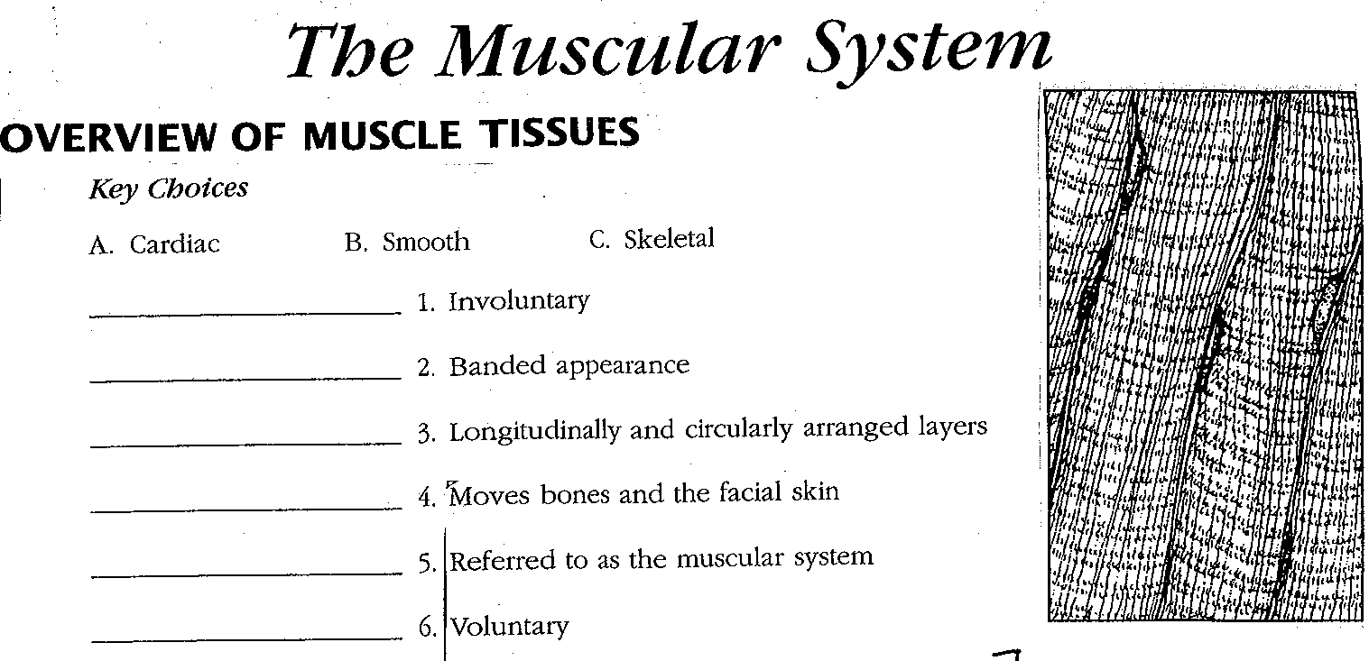

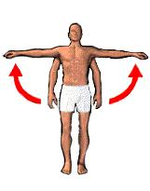**Muscle Movements:**

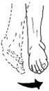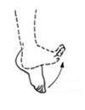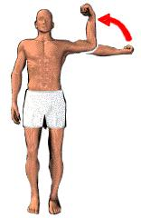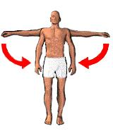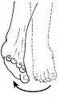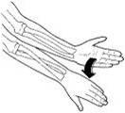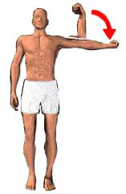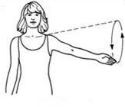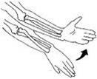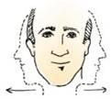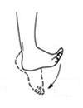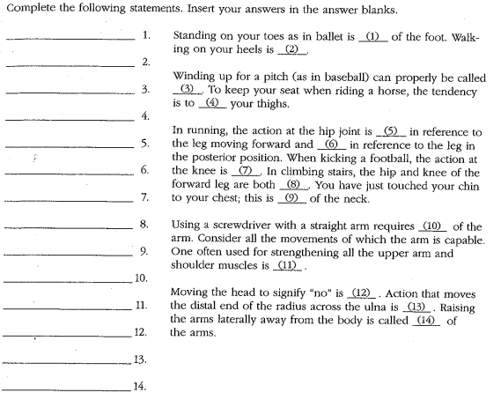

**Muscle Movements, Types, & Names:** List 6 ways muscles can be named.

Label the diagram below using the word bankGive an example of a muscle for each

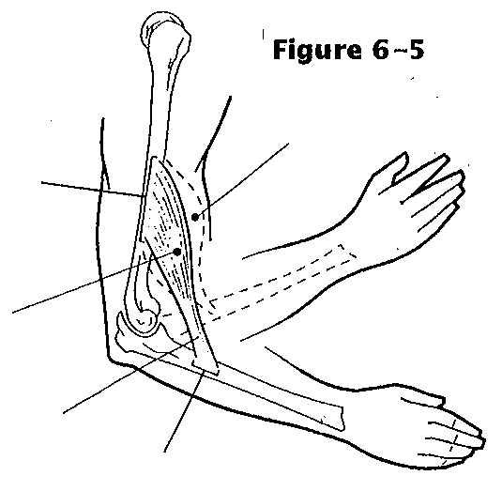

1.

Ex.

2.

Ex.

3.

Ex.

4.

Ex.

5.

Ex.

6.

Ex.

**Word Bank**

Immovable Bone

Movable Bone

Origin

Insertion

Resting Muscle

Contracting Muscle

Tendon

**Label the Sarcomere:**

Actin Myosin A Band I Band H Zone Z Line Sarcomere

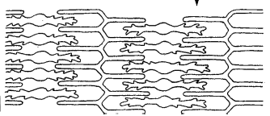

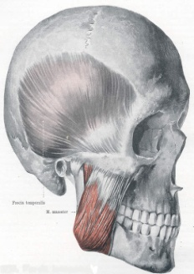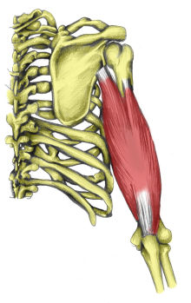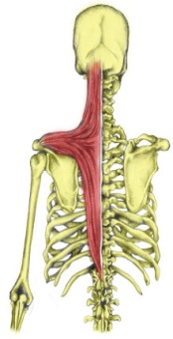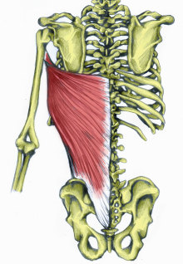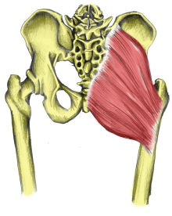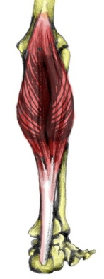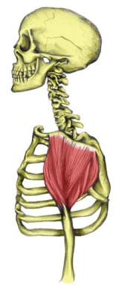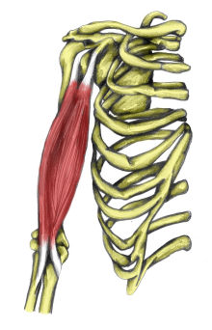**OIA Muscles**

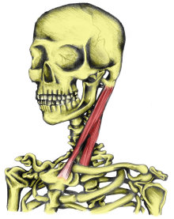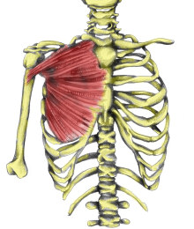

|  |  |  |  |
| --- | --- | --- | --- |
| **Muscle** | **Origin** | **Insertion** | **Action** |
| **Trapezius** |  |  |  |
| **Latissimus Dorsi** |  |  |  |
| **Sternocleidomastoid** |  |  |  |
| **Masseter** |  |  |  |
| **Biceps Brachii** |  |  |  |
| **Deltoid** |  |  |  |
| **Triceps Brachii** |  |  |  |
| **Gluteus Maximus** |  |  |  |
| **Gastrocnemius** |  |  |  |
| **Pectoralis Major** |  |  |  |

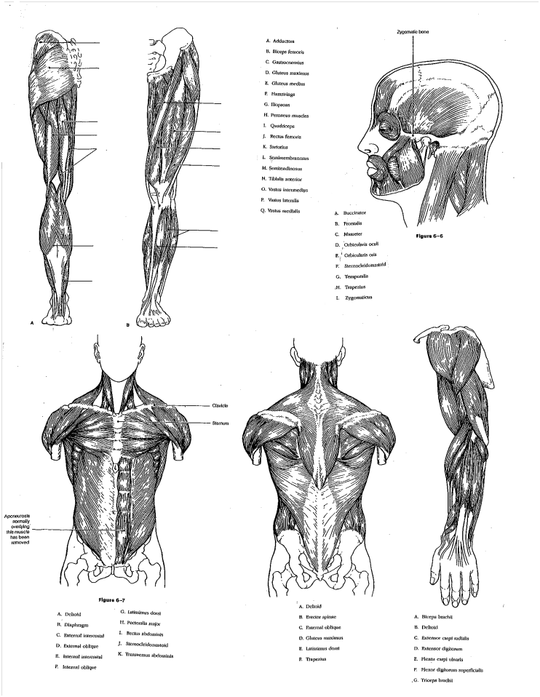**Muscle Identification:**

